GitHub Copilot

Accelerate app development by using GitHub Copilot
Learn what GitHub Copilot is and how it helps developers.
Explore Copilot tools, features, limitations, and subscription options.
Install and configure Copilot + Copilot Chat in VS Code.
Understand how Copilot improves speed, accuracy, and productivity in software development.
You're a developer with:
- a tight deadline,
- a large codebase you haven’t seen before,
- the need to write clean, bug-free code quickly.
GitHub Copilot helps by:
- Explaining unfamiliar code.
- Suggesting code completions.
- Generating documentation.
- Assisting with debugging and feature development.

AI Tools from GitHub, OpenAI, and Microsoft
AI tools help developers automate coding tasks, improve quality, and increase productivity. The following tools support different development needs such as building AI apps, generating code, creating chatbots, or integrating models into existing apps.
1. Foundry Tools- Cloud-based AI services for adding AI features without ML expertise.
Key Capabilities
- Prebuilt models (text analysis, image recognition, translation).
- REST APIs and SDKs.
- Easy integration into existing apps.
Best For
- Developers needing AI without building models.
- Quick deployment of common AI features.
- Projects needing speech, NLP, or computer vision.
2. Microsoft Foundry Portal- A no-code/low-code web platform to build, train, and deploy ML models.
Key Features
- Drag-and-drop ML pipelines.
- Supports TensorFlow & PyTorch.
- Tools for data prep, training, evaluation.
- Deploy as web services.
Best For
- Developers experimenting with ML without writing code.
- Data scientists wanting a visual interface.
- Custom ML models for specific business needs.
3. AI Builder (Power Platform)- Add AI to apps in Power Apps without coding.
Capabilities
- Prebuilt models: prediction, form processing, object detection, text classification.
- Create custom models using your data.
- Integrates seamlessly with Power Apps.
Best For
- Business analysts & citizen developers.
- Automating business processes.
- AI features in low-code apps.
4. Copilot Studio-A tool to build and manage AI-powered chatbots (copilots).
Features
- Visual conversational flow designer.
- Supports NLU & NLG.
- Templates and analytics dashboard.
- Works in a web app or Teams.
Use Cases
- Customer support bots.
- HR/employee self-service.
- Public info and FAQ automation.
Best For
- Non-developers making chatbots.
- Organizations automating conversations.
- Projects needing multi-channel chatbots.
5. Semantic Kernel SDK-Framework for building AI agents that interact with existing code.
Key Capabilities
- Connect AI models to C#, Python, Java code.
- Use AI responses to trigger actions.
- Supports OpenAI, Azure OpenAI, Hugging Face.
Best For
- Developers integrating AI into existing systems.
- Automated workflows or AI agents.
- Apps needing AI-driven decision-making.
6. Visual Studio IntelliCode-AI-assisted development in Visual Studio.
Features
- Smart code completions.
- Refactoring guidance.
- Code style consistency.
Best For
- Developers wanting productivity boosts.
- Teams enforcing consistent code quality.
7. ChatGPT (OpenAI)-General-purpose conversational AI.
Use Cases
- Generating ideas or explanations.
- Simple code samples (must verify).
- Debugging help.
- Brainstorming.
Best For
- High-level discussions.
- Concept clarification.
- Conversational AI apps.
(Not the best choice for direct IDE-integrated coding.)
8. GitHub Copilot & Copilot Chat-AI pair programmer integrated directly in IDEs.
Copilot Features
- Context-aware autocompletion.
- Full functions/classes generated from prompts.
- Supports many languages & frameworks.
Copilot Chat Features
- Code explanations.
- Test case generation.
- Debugging assistance.
- Documentation creation.
- Code refactoring suggestions.
Best For
- Developers writing code daily.
- Teams improving consistency + quality.
- Projects requiring fast development cycles.
✅ Overall Summary
Tool | Best For
Foundry Tools | Add ready-made AI capabilities without ML expertise
Microsoft Foundry Portal | Building ML models visually with no coding
AI Builder | Adding AI to Power Platform apps
Copilot Studio | Creating chatbots easily
Semantic Kernel | Building AI agents integrated with real code
IntelliCode | AI-powered coding inside Visual Studio
ChatGPT | Explanations, brainstorming, conceptual help
GitHub Copilot | Hands-on coding, completion, debugging, test generation

GitHub Copilot Plans
GitHub Copilot offers multiple subscription tiers designed for individuals, teams, and enterprises. Each plan provides different features, levels of access, and administrative capabilities.
1. Copilot Free (Individual)
Who it's for: Individual developers without an organization/enterprise subscription.
Key Features:
- Free access to a limited set of Copilot features.
- Basic AI coding assistance.
- Limited Copilot Chat capabilities.
- Good for beginners evaluating Copilot.
Best For: Trying out Copilot with no cost.
2. Copilot Pro (Individual – Paid)
Who it's for: Professional developers who want full access on personal projects.
Key Features:
- Unlimited code completions.
- Premium Copilot Chat models.
- Monthly allowance of premium (higher-tier) AI requests.
- Full IDE support.
Eligibility for free access:
- Verified students
- Teachers
- Maintainers of popular open-source projects
Best For: Full personal use with strong coding + chat capabilities.
3. Copilot Pro+ (Individual – Premium)
Who it's for: AI power users and developers needing expanded AI capacity.
Key Features (in addition to Pro):
- Larger allowance of premium AI requests.
- Full access to all Copilot Chat models.
- Best performance and highest availability.
Best For: Heavy Copilot users who want maximum model access and high request limits.
4. Copilot Business (Organizations)
Who it's for: Companies using GitHub Free, Team, or Enterprise Cloud.
Key Enterprise Features:
- Centralized admin controls and policy management.
- Manage Copilot access for all members.
- Data protection & enterprise security controls.
- Ensures organization-wide compliance.
Best For: Teams wanting controlled, secure usage of Copilot.
5. Copilot Enterprise (Large Organizations)
Who it's for: Github Enterprise Cloud customers requiring advanced, org-wide AI features.
Includes everything in Copilot Business, plus:
- Additional enterprise-grade features.
- Enhanced security/compliance.
- Ability to assign Copilot Enterprise or Copilot Business to different organizations within the enterprise.
Best For: Large enterprises needing high-level governance, scalability, and advanced AI capabilities.
Plan | Audience | Access Level | Admin Controls | Chat Models | Notes
Free | Individuals | Limited | No | Basic | Best for beginners
Pro | Individuals | Full | No | Premium | Unlimited completions
Pro+ | Individuals | Full + Max limits | No | All models | For power users
Business | Orgs & Teams | Full | Yes | Premium | Centralized management
Enterprise | Enterprise Cloud | Full + Enterprise features | Yes | Premium/Enterprise | Best for large companies
Comparing GitHub Copilot plans
Feature | Copilot Free | Copilot Pro | Copilot Pro+ | Copilot Business | Copilot Enterprise
Premium requests | 50 per month | 300 per month | 1500 per month | 300 per user per month | 1000 per user per month
Purchase additional premium requests | X | ✓ | ✓ | ✓ | ✓
Pricing
Agents
Feature | Copilot Free | Copilot Pro | Copilot Pro+ | Copilot Business | Copilot Enterprise
Agent mode in Visual Studio Code | ✓ | ✓ | ✓ | ✓ | ✓
Copilot code review | Only "Review selection" in Visual Studio Code | ✓ | ✓ | ✓ | ✓
Copilot Extensions | ✓ | ✓ | ✓ | ✓ | ✓

Chat
Feature | Copilot Free | Copilot Pro | Copilot Pro+ | Copilot Business | Copilot Enterprise
Copilot Chat in IDEs | 50 messages per month | Unlimited with base model | Unlimited with base model | Unlimited with base model | Unlimited with base model
Inline chat | ✓ | ✓ | ✓ | ✓ | ✓
Slash commands | ✓ | ✓ | ✓ | ✓ | ✓
Copilot Chat in GitHub Mobile | ✓ | ✓ | ✓ | ✓ | ✓
Copilot Chat in GitHub | ✓ | ✓ | ✓ | ✓ | ✓
Copilot Chat in Windows Terminal | ✓ | ✓ | ✓ | ✓ | ✓
Increased GitHub Models rate limits | X | X | ✓ | ✓ | ✓
Copilot Chat skills in IDEs | X | ✓ | ✓ | ✓ | ✓
Models
Available Models in Chat | Copilot Free | Copilot Pro | Copilot Pro+ | Copilot Business | Copilot Enterprise
Claude 3.5 Sonnet | ✓ | ✓ | ✓ | ✓ | ✓
Claude 3.7 Sonnet | X | ✓ | ✓ | ✓ | ✓
Claude 3.7 Sonnet Thinking | X | ✓ | ✓ | ✓ | ✓
Gemini 2.0 Flash | ✓ | ✓ | ✓ | ✓ | ✓
Gemini 2.5 Pro | X | ✓ | ✓ | ✓ | ✓
GPT-4o | ✓ | ✓ | ✓ | ✓ | ✓
GPT-4.1 | ✓ | ✓ | ✓ | ✓ | ✓
GPT-4.5 | X | X | ✓ | X | ✓
o1 | ✓ | ✓ | ✓ | ✓ | ✓
o3 | X | X | ✓ | X | ✓
o3-mini | ✓ | ✓ | ✓ | ✓ | ✓
o4-mini | X | ✓ | ✓ | ✓ | ✓

Code completion
Feature | Copilot Free | Copilot Pro | Copilot Pro+ | Copilot Business | Copilot Enterprise
Real-time code suggestions with the base model | 2000 completions per month | ✓ | ✓ | ✓ | ✓
Next edit suggestions | ✓ | ✓ | ✓ | ✓ | ✓
Customization
Feature | Copilot Free | Copilot Pro | Copilot Pro+ | Copilot Business | Copilot Enterprise
Repository and personal custom instructions | ✓ | ✓ | ✓ | ✓ | ✓
Organization custom instructions (public preview) | X | X | X | X | ✓
Prompt files | ✓ | ✓ | ✓ | ✓ | ✓
Private extensions | ✓ | ✓ | ✓ | ✓ | ✓
Coding guidelines for code review | X | X | X | X | ✓
Block suggestions matching public code | ✓ | ✓ | ✓ | ✓ | ✓
Exclude specified files from Copilot | X | X | ✓ | ✓ | ✓
Organization-wide policy management | X | X | ✓ | ✓ | ✓
Other features
Feature | Copilot Free | Copilot Pro | Copilot Pro+ | Copilot Business | Copilot Enterprise
Copilot generated pull request summaries | X | ✓ | ✓ | ✓ | ✓
Audit logs | X | X | ✓ | ✓ | ✓
Copilot knowledge bases | X | X | X | X | ✓
Fine tuning a custom large language model (limited public preview) | X | X | X | X | ✓
Copilot in the CLI | ✓ | ✓ | ✓ | ✓ | ✓

GitHub Copilot Features
GitHub Copilot includes a wide range of AI-powered tools designed to improve coding speed, accuracy, and productivity. Features vary depending on your Copilot plan (Free, Pro, Business, Enterprise).
1. Code Completion (General Availability)
- Autocomplete-style AI code suggestions in supported IDEs:
VS Code, Visual Studio, JetBrains IDEs, Azure Data Studio, Xcode, Vim/Neovim, Eclipse
- Can suggest:
  - Entire lines
  - Entire blocks
  - Full functions or classes
- VS Code only: Next-edit predictions (suggests what your next change is likely to be)
2. Copilot Chat
- Chat interface for asking coding questions directly inside:
  - GitHub.com
  - GitHub Mobile
  - VS Code
  - Visual Studio
  - JetBrains IDEs
  - Eclipse
  - Xcode
  - Windows Terminal
- Can:
  - Explain code
  - Fix issues
  - Update files
  - Generate documentation and test cases
  - Use GitHub Skills (not available on Copilot Free)
3. Copilot Edits (VS Code + JetBrains)
AI-assisted multi-file editing with two modes:
a. Edit Mode
- You control:
  - Which files Copilot can modify
  - What context to provide
  - Whether to accept each proposed change
- Good for careful, iterative editing.
b. Agent Mode (VS Code only)
- Copilot autonomously:
  - Selects files to change
  - Writes and refines code
  - Runs commands if needed
  - Iterates until task completion
- Good for high-level tasks (e.g., “Add logging to all controllers”).
4. GitHub Copilot Code Review
- Provides AI-powered review suggestions.
- Helps catch bugs, improve readability, and ensure best practices.
5. Copilot in the CLI
- Chat-like assistant inside the terminal.
- Can:
  - Explain commands
  - Suggest terminal commands
  - Integrate with Windows Terminal Canary
- Useful for DevOps and shell workflows.
6. AI-Generated Pull Request Summaries
- Auto-generated PR summaries describing:
  - Changes made
  - Files impacted
  - Key focus areas for reviewers
- Not available in Copilot Free.
7. GitHub Copilot Extensions
- Allows external tools to plug into Copilot Chat.
- Built as GitHub Apps → can be public or private.
- Extends Copilot with specialized workflows (e.g., security, testing, infrastructure tools).
8. Copilot Custom Instructions
- Lets you define:
  - Preferred coding style
  - Tech stack
  - Project context
  - Rules or constraints
- Helps Copilot produce more personalized responses.
9. Copilot Knowledge Bases (Enterprise Only)
- Lets organizations add internal documentation as context for Copilot Chat.
- Useful for:
  - Onboarding
  - Internal frameworks
  - Proprietary codebases
- Chat queries can reference a selected knowledge base.

GitHub Copilot Setup
1. Setup for Individual Users
1. Choose a Copilot Plan
Individuals can access Copilot through multiple options:
- Copilot Free
  - Up to 2,000 completions + 50 chats/premium requests per month.
- Copilot Pro
  - 30-day free trial
  - 300 premium requests/month
- Copilot Pro+
  - 1,500 premium requests/month
  - Full access to all available models.
- Through your organization/enterprise
  - Access provided by the company’s Copilot plan.
- Free for verified students, teachers, OSS maintainers
2. Install the Copilot Extension
Install the GitHub Copilot extension in your preferred IDE:
- VS Code
- Visual Studio
- JetBrains (IntelliJ, PyCharm, etc.)
- Vim/Neovim
- Eclipse
- Xcode
For Terminal Use
- Install the Copilot extension for GitHub CLI
- Optionally connect Copilot to Windows Terminal Canary for chat support.
3. Networking Requirements (If Needed)
- If behind a proxy or firewall, add required GitHub URLs to the allowlist.
- May need to install custom SSL certificates.
4. Configure Settings
You can configure Copilot settings in the IDE or CLI.
Users with their own individual subscription can:
- Install Copilot Extensions (integrate external tools into Copilot Chat)
- Manage their own Copilot policies
2. Setup for Organizations
1. Subscribe to a Copilot Plan
- Enable Copilot Business for the organization
OR
- Enterprise owners can enable Copilot Enterprise or Copilot Business for individual organizations.
2. Configure Policies
Organizations can control:
- Which Copilot features members can use
- Security & privacy settings
- Allowed or blocked Copilot integrations
3. Networking Setup
If members use proxies/firewalls:
- Add required GitHub URLs to allowlists
- Install custom SSL certificates on member machines
4. Grant User Access
- Enable Copilot for specific teams or members
- Recommended rollout pattern:
  - Start with motivated early adopters
  - Identify blockers early
  - Expand organization-wide gradually
- Many successful organizations use “self-service licensing”—developers claim a seat without manual approval.
5. Extra Steps for Enterprise Cloud
Users must complete extra authentication steps in their IDE.
6. Drive Adoption
Successful adoption usually includes:
- Training
- Documentation
- Internal champions
- Feedback loops
7. Enhance Copilot for the Organization
- Knowledge bases (Enterprise only)
  - Add internal documentation as context for Copilot Chat
- Custom LLM fine-tuning
- Install Copilot Extensions to integrate tools into Copilot Chat
3. Access to Copilot Free
Most users can start Copilot Free immediately, except when:
- Using a managed user account
- Assigned a Copilot seat through an organization
- Already have Copilot Pro/Pro+/trial
- Are using a free educational/OSS Copilot Pro license
Where You Can Enable Copilot Free
- VS Code / Visual Studio → Sign in → Activate Copilot Free in the editor
- GitHub.com → Settings → Your Copilot → Start using Copilot Free
- GitHub Mobile → Tap the Copilot icon → Ask Copilot
- Other IDEs → Must first activate Copilot Free in GitHub settings

Configure GitHub Copilot in Visual Studio Code
GitHub Copilot integrates natively with Visual Studio Code (VS Code) using two extensions:
- GitHub Copilot – provides code completions and suggestions
- GitHub Copilot Chat – provides the chat interface, explanations, edits, and AI assistance
Both extensions install automatically during the setup process.
1. Install GitHub Copilot in Visual Studio Code
Steps to install and activate:
- Open Visual Studio Code (ensure it's up to date).
- Hover over the GitHub Copilot icon in the Status Bar → click Set up Copilot.
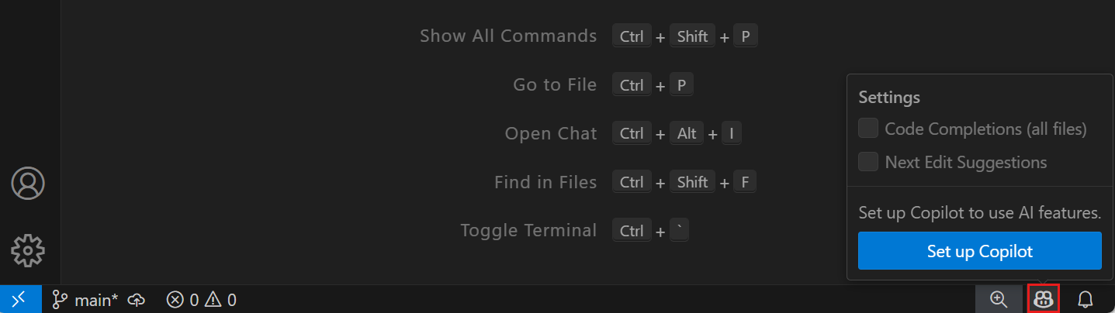
- In the Sign in to use Copilot dialog:
  - Select Sign in (or Use Copilot if already authenticated).
- The browser opens → log in to GitHub → authorize VS Code.
- If you don’t have a subscription, you’ll automatically be placed on Copilot Free.
What happens automatically:
- VS Code installs the GitHub Copilot and GitHub Copilot Chat extensions in the background.
- You can review them in the Extensions panel.
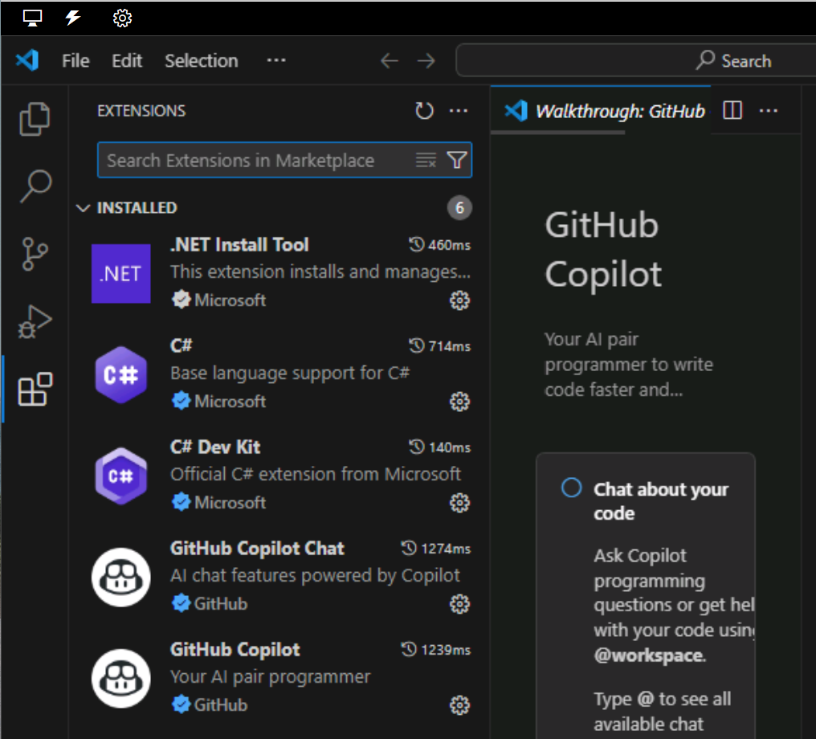
2. Configure Copilot Settings in VS Code
You can customize Copilot behavior using the VS Code Settings menu.
How to open settings:
- Select Manage (⚙️ gear icon) in the bottom-left corner
- Click Settings
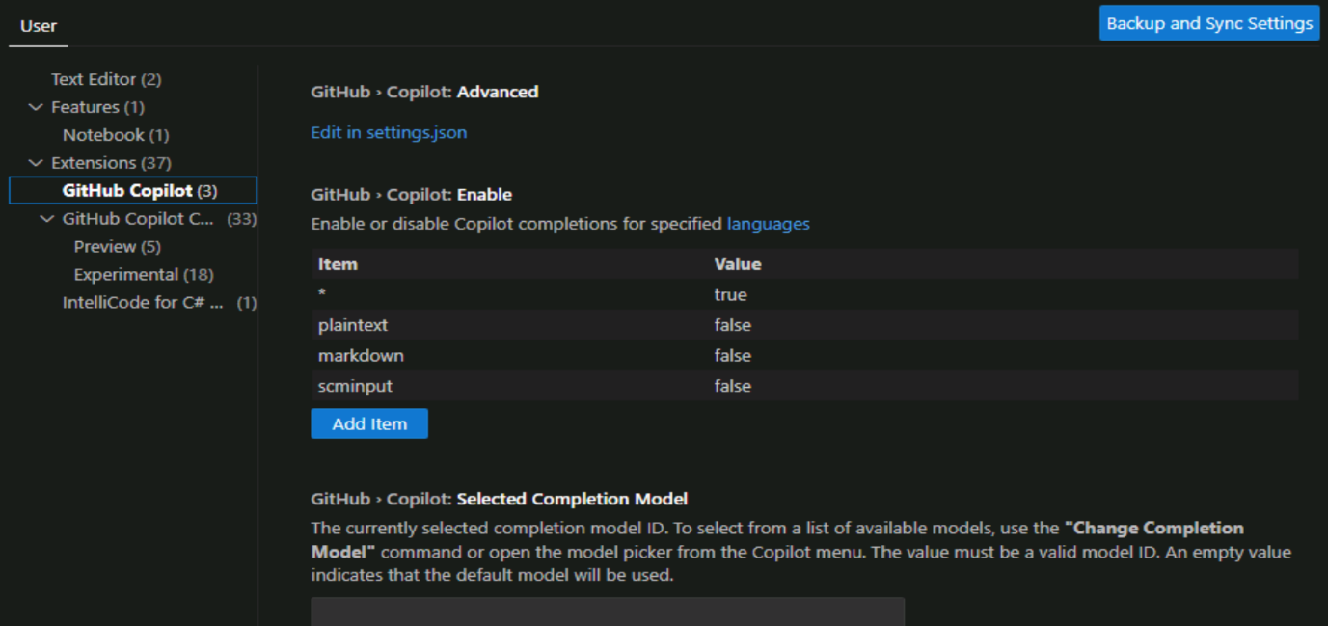
3. GitHub Copilot Extension Settings (Code Completions)
These settings manage the core functionality of GitHub Copilot, such as:
- Choosing which programming languages Copilot is enabled for
- Selecting the AI model (if available in your plan)
- Controlling how suggestions appear (inline, ghost text, multiline, etc.)
- Turning Copilot on/off per workspace or globally
Use these settings if you want to adjust how Copilot suggests code.
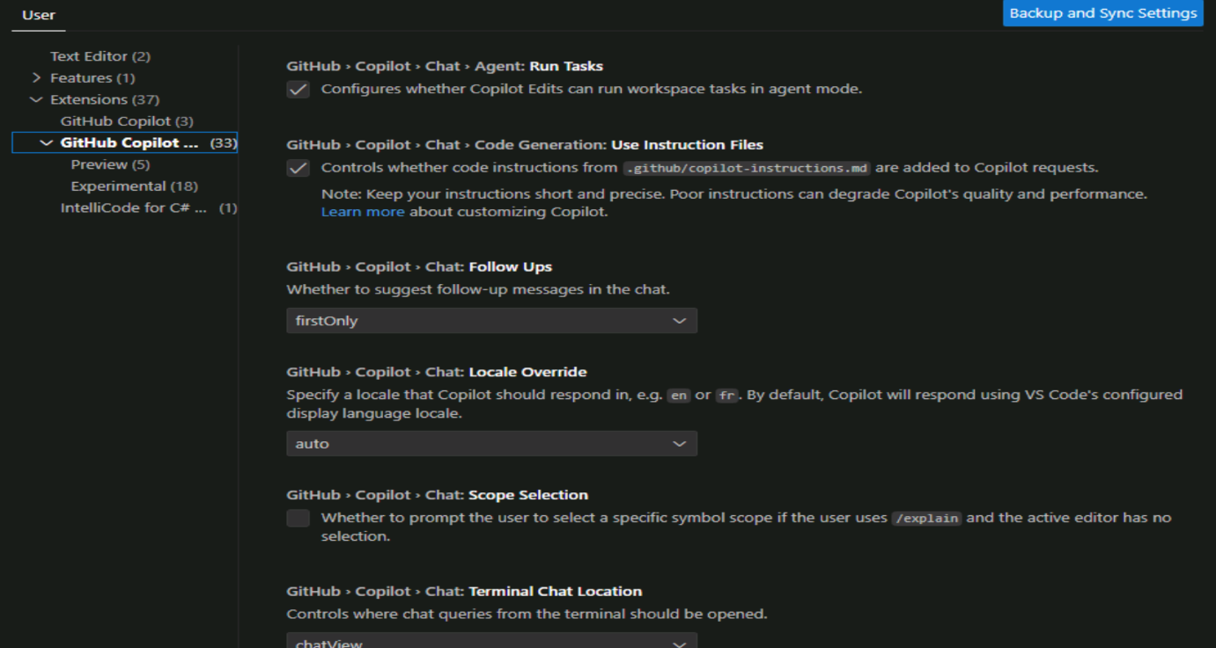
4. GitHub Copilot Chat Extension Settings (Chat Features)
These settings control the chat experience, such as:
- Chat behavior and response formatting
- Permissions for the chat to modify files
- Conversation history and context handling
- Model selection (depending on your plan)
Use these settings to customize how you interact with Copilot Chat, including editing, debugging, and asking questions.
Summary
Feature | GitHub Copilot Extension | GitHub Copilot Chat Extension
Purpose | Code completions + suggestions | Chat, explanations, multi-file edits
Installed automatically? | Yes | Yes
Configurable? | Yes (languages, models, completions) | Yes (chat behavior, file edits, context)
Where to manage? | VS Code Settings → Extensions → GitHub Copilot | VS Code Settings → Extensions → GitHub Copilot Chat

Manage GitHub Copilot Policies, Features & Extensions (Individual Users)
GitHub Copilot can be customized through your GitHub account settings and your IDE settings. Individual users can manage plans, features, privacy options, and extensions — unless restricted by an organization.
1. Managing Copilot Features (Individual Account Settings)
You can enable/disable several Copilot features directly in your GitHub account:
Copilot Chat in GitHub
- Enables chat on GitHub.com
- Preview features not included
- Enabled by default
Copilot Chat in GitHub Desktop
- Allows AI assistance in GitHub Desktop
- Enabled by default
Web Search in Copilot Chat
- Copilot can use Bing to search the internet for additional information
- Useful for new technologies or niche topics
- Optional toggle
Alternative AI Models
You may allow Copilot to use:
- Anthropic Claude Sonnet
- Google Gemini
as alternatives to the default model.
2. Privacy-Related Settings
Suggestions Matching Public Code
Controls whether Copilot suggests code resembling public GitHub code.
- Allow → Suggestions may match public code; shows match details
- Block → Copilot suppresses suggestions that resemble public code (150-character similarity check)
⚠ If you're on an organization’s Copilot Business/Enterprise plan, this setting is controlled by the organization and cannot be changed individually.
Prompt and Suggestion Collection
Choose whether GitHub can use:
- your prompts
- Copilot’s suggestions
for product improvement.
Toggle via Your Copilot → “Allow GitHub to use my code snippets…”
Model Training
Your data is not used for AI model training.
This setting cannot be enabled.
3. Managing Copilot Extensions (Personal Account)
What are Copilot Extensions?
- GitHub Apps that enhance Copilot Chat with extra capabilities
- Installed from the GitHub Marketplace
- Anyone can install them, but requires:
  - Copilot Free, or
  - Copilot Pro / Pro+
Notes
- If you use Copilot through your organization, extensions are installed at the org level by org owners.
- You can also build custom Copilot Extensions.
4. Limitations of GitHub Copilot Chat
GitHub Copilot Chat is powerful, but not perfect. Limitations include:
🔹 Limited Scope
- Works best with well-represented languages like JavaScript
- Struggles with obscure languages or complex architectures
🔹 Potential Biases
- May reflect biases or errors in training data
- Preferences toward certain styles or languages
🔹 Security Risks
- Generated code may include vulnerabilities
- Must review & test generated code
- Avoid auto-running unreviewed code
🔹 Public Code Matches
- Although rare, suggestions may resemble public code
- Filters help block obvious matches
- Treat suggestions like third-party code → scan, test, validate
🔹 Inaccurate or Misleading Code
- Code may look correct but be syntactically/semantically wrong
- Always review before integrating
🔹 Poor Performance on Non-Coding Topics
- Not optimized for general knowledge questions
- Responses may be irrelevant or incorrect

GitHub Copilot Code Completion Features (Explained Clearly)
GitHub Copilot provides autocomplete-style suggestions while you write code or comments. It accelerates development by predicting what code you want next and letting you accept, refine, or replace suggestions.
You receive suggestions when you:
- Type part or all of a code line
- Type a comment
- Enter a blank line
1. How GitHub Copilot Generates Autocomplete Suggestions
Copilot analyzes your code context and predicts your next lines.
Example: Simple C# method
When typing:
int addInt(int a, int b)
Copilot suggests completing the method body automatically.
Suggestions appear gray and unformatted, so you can distinguish them from your real code.
Accepting or dismissing
- Tab → Accept full suggestion
- Esc → Dismiss suggestion
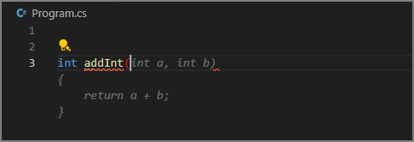
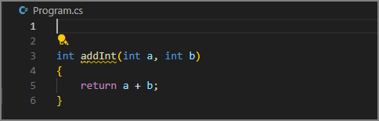
2. More Complex Predictions
Copilot also predicts multi-step workflows.
Example: Sum prime numbers
When typing:
int addPrimeNumbersInNumericList(List<int> numbers)
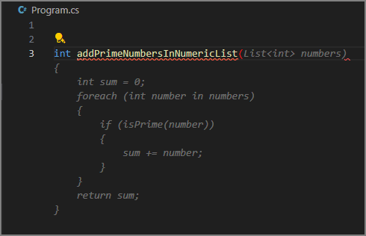
Copilot may generate:
- The full method
- References to helper functions (e.g., isPrime) that don’t exist yet
- Suggestions for those missing helper functions when you create a new blank line
This demonstrates that Copilot tries to follow best practices by encouraging smaller, modular methods.
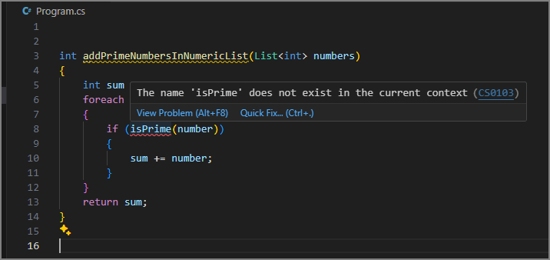
3. Managing Autocomplete Suggestions
When hovering over a suggestion, Copilot shows controls that let you manage, refine, or explore alternatives.
Available actions
✔ Accept
Accept the suggestion fully.
- Click Accept Or press Tab
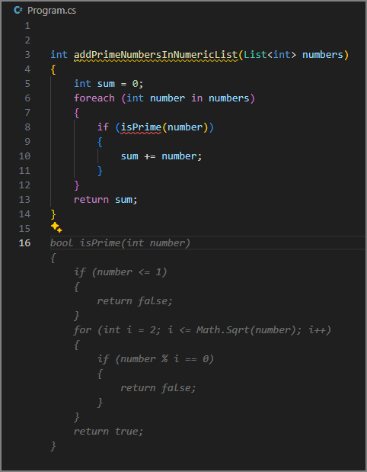
✔ Accept Word (partial accept)
Accepts only the next word.
Useful if Copilot’s idea is close but not exact.
- Click Accept Word Or press Ctrl + >
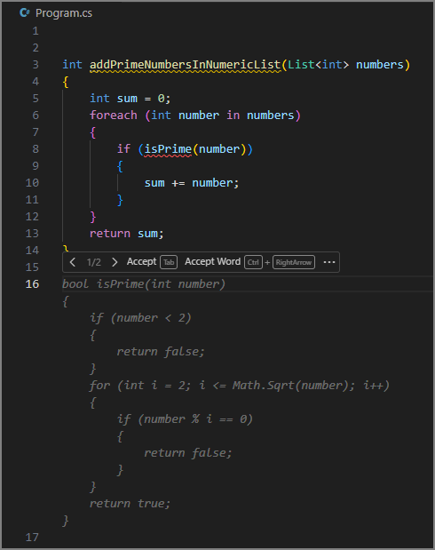
✔ View alternate suggestions
Browse variations of the completion.
- Use > and < buttons
- Or press:
  - Alt + ] (next)
  - Alt + [ (previous)
✔ Additional options under the ellipsis (…)
- Accept Line → Accept only one full line
- Always Show Toolbar → Keeps controls visible
- Open Completions Panel → Opens a full panel of alternative suggestions
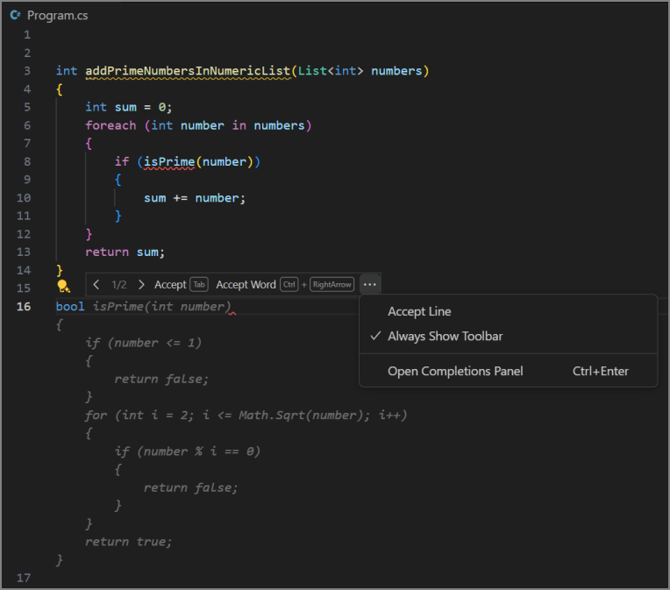
4. Generate Code from Comments (Natural Language → Code)
Copilot can turn your comments into code.
Example:
Typing a comment like:
// create a list of 100 random numbers between 1 and 1000
will make Copilot generate:
- the completed comment
- code that satisfies the comment’s description
- supporting steps (variable declarations, loops, logic)
- follow-up code suggestions (like method calls)
Copilot continuously updates suggestions as you keep typing the comment.
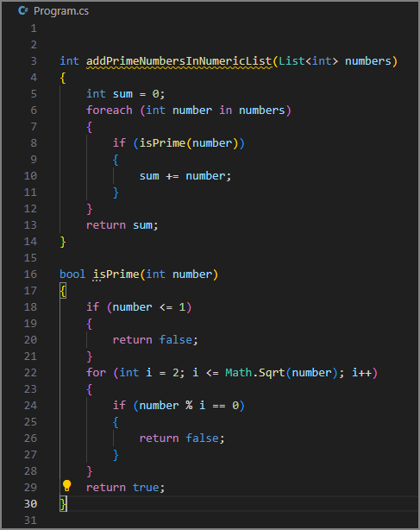
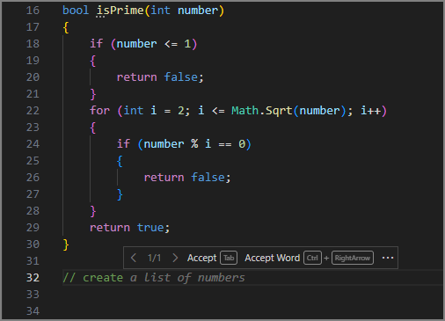
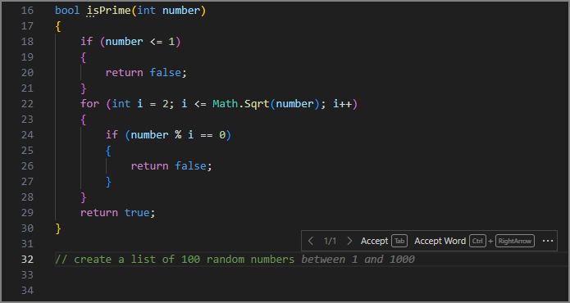
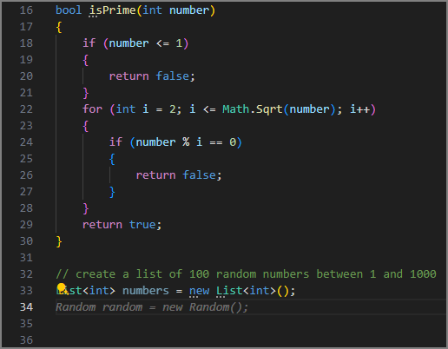
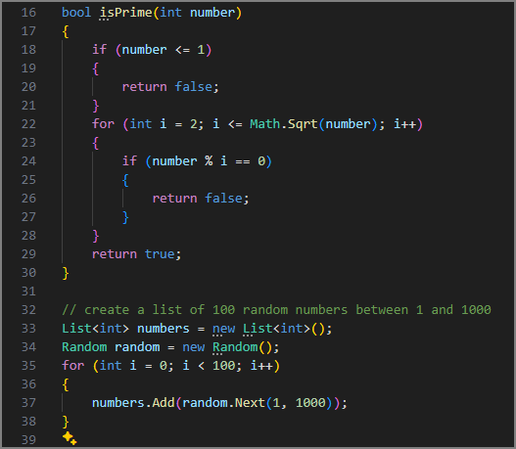
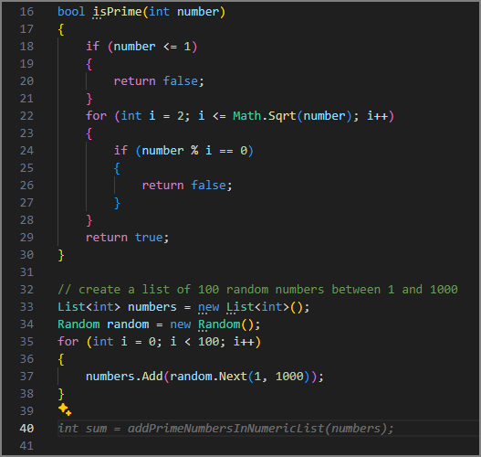5. Using the GitHub Copilot Suggestions / Completions Panel
If you want more options beyond the inline suggestions, you can open a dedicated panel.
How to open the panel
- Press Ctrl + Enter
- Or from the autocomplete toolbar, choose Open Completions Panel
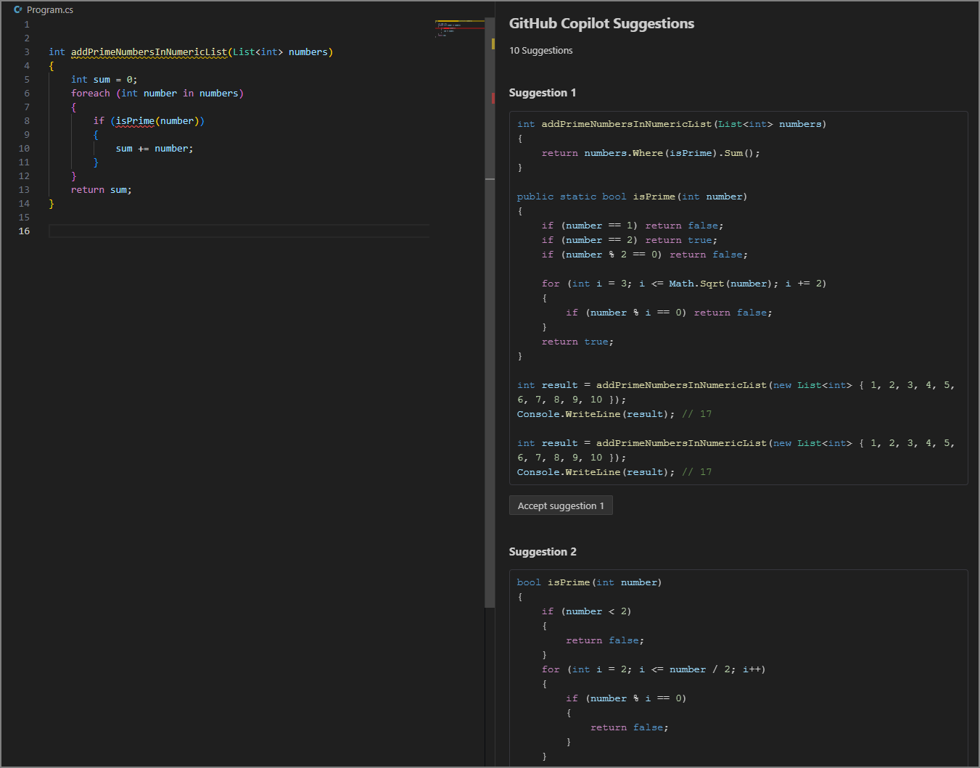
Panel capabilities
- Shows up to 10 alternative suggestions
- Each suggestion includes code Copilot generated from your context
- You can:
  - Accept a specific suggestion
  - Close the panel to reject all
This is especially useful when:
- Copilot’s first suggestion isn’t ideal
- You’re solving a complex problem
- You want to compare algorithm choices
📌 Summary of Key Commands
Action | Command
Accept suggestion | Tab
Dismiss | Esc
Accept word | Ctrl + >
Cycle suggestions | Alt + ], Alt + [
Open suggestions panel | Ctrl + Enter

GitHub Copilot’s AI Assistance Features (Visual Studio Code)
GitHub Copilot Chat integrates directly into Visual Studio Code and provides real-time, context-aware help right where you're working. It assists with understanding code, fixing bugs, generating tests, answering questions, and more.
🔹 Ways to Access Copilot Chat in VS Code
You can access Copilot Chat in multiple ways:
1. Chat View (Full AI assistant panel)
A sidebar where you can freely chat with the AI, ask questions, or request explanations.
2. Inline Chat (Right inside the editor)
Start a conversation directly next to your code for focused help.
3. Smart Actions
Prebuilt quick actions like:
- “Explain this code”
- “Fix this”
- “Add documentation”
These eliminate the need to write a prompt at all.
4. Quick Chat
A lightweight popup for quick questions or clarifications without leaving your workflow.
🔹 Use Cases for Copilot Chat
Copilot Chat helps across nearly all coding scenarios. Here’s how:
1. Explaining & Documenting Code
Copilot can:
- Explain selected code in plain language
- Describe purpose, inputs, outputs
- Summarize dependencies
- Provide context within the broader system
This helps developers understand unfamiliar code and generate documentation for teammates or nontechnical stakeholders.
2. Answering Coding Questions
You can ask Copilot:
- How to solve a specific problem
- How a library or API works
- How to write something in a certain programming language
Responses may include natural-language explanations or code snippets.
3. Proposing Bug Fixes
With context from your code or error messages, Copilot can:
- Suggest fixes
- Identify problematic logic
- Recommend changes to variables, conditions, or function calls
Important: Suggestions must still be reviewed and tested manually.
4. Generating Unit Test Cases
Copilot Chat can generate:
- Example test structures
- Input and expected output values
- Assertions
- Edge-case tests (nulls, errors, boundaries)
This helps automate repetitive test-writing tasks but doesn’t replace thorough manual testing.
5. Suggesting Improvements to Existing Code
Copilot can propose improvements across:
✔ Code Quality
Refactoring, simplifying logic, improving naming, modularizing code.
✔ Code Reliability
Adding error handling, validations, defensive checks.
✔ Performance
Suggesting better algorithms, optimizing data structures, or using parallelization.
✔ Security
Recommendations like input sanitization, safer patterns, encryption, or secure access controls.
These suggestions help developers improve maintainability, efficiency, and security.
🔹 How GitHub Copilot Chat Works
Copilot Chat uses natural language processing (NLP) and machine learning to convert your prompt into a relevant answer. The process includes:
1. Input Processing
Your prompt—code snippet or plain language—is cleaned and sent to the AI model.
2. Language Model Analysis
The model analyzes:
- Your question
- The surrounding context
- Relevant code files
3. Response Generation
The model creates:
- Code
- Explanations
- Fixes
- Suggestions
4. Output Formatting
Copilot presents:
- Syntax-highlighted code
- Structured explanations
- Links to relevant files or documentation
You must still review and validate all generated content.

GitHub Copilot Chat View (VS Code)
The Chat view is the main interface for interacting with GitHub Copilot Chat. By default, it’s in the Secondary Side Bar (right side of VS Code).
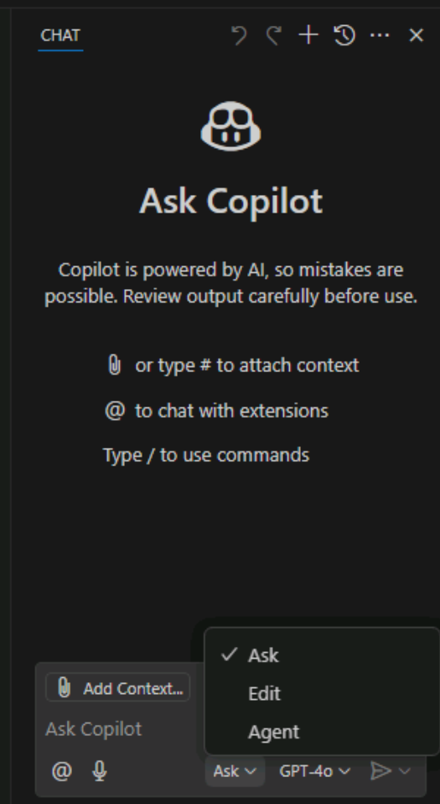
Layout of the Chat view:
- Toolbar – Top of the panel, contains controls for actions like undo/redo edits.
- Display area – Center section, shows chat history and AI responses.
- Input & control menu – Bottom section, where you type prompts and add context.
Opening the Chat view:
- Click the Toggle Chat button (Copilot icon)
- Or use the shortcut: Ctrl + Alt + I
🔹 Chat Modes
1. Ask Mode
- Purpose: Ask questions about code, technology concepts, or general coding help.
- Use case: Explaining code, suggesting revisions, or understanding a codebase.
- Output: AI responds with natural language explanations and code snippets.
- Applying code suggestions:
  - Hover over a code block → Apply in Editor
  - Or copy/insert at cursor
  - Shell commands can be run directly in the terminal (Ctrl + Alt + Enter)
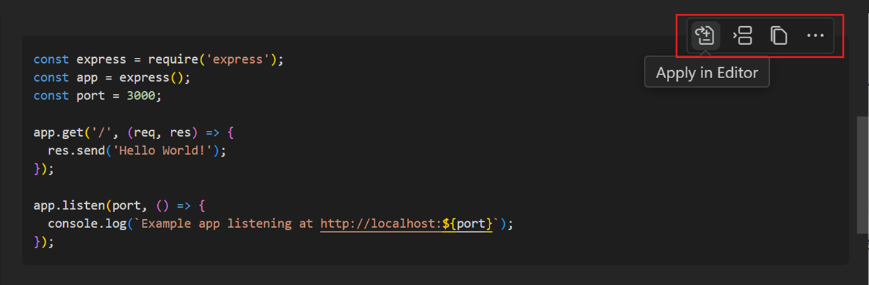
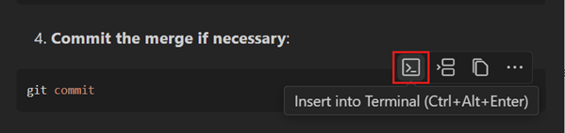
2. Edit Mode
- Purpose: Make in-place code updates across one or multiple files.
- Use case: Refactoring, adding comments, or applying changes suggested by the AI.
- Output: Suggested edits appear in the editor with descriptions in the Chat view.
- Actions:
  - Keep or Undo edits (entire set or individually)
  - Undo Last Edit / Redo Last Edit controls available in toolbar
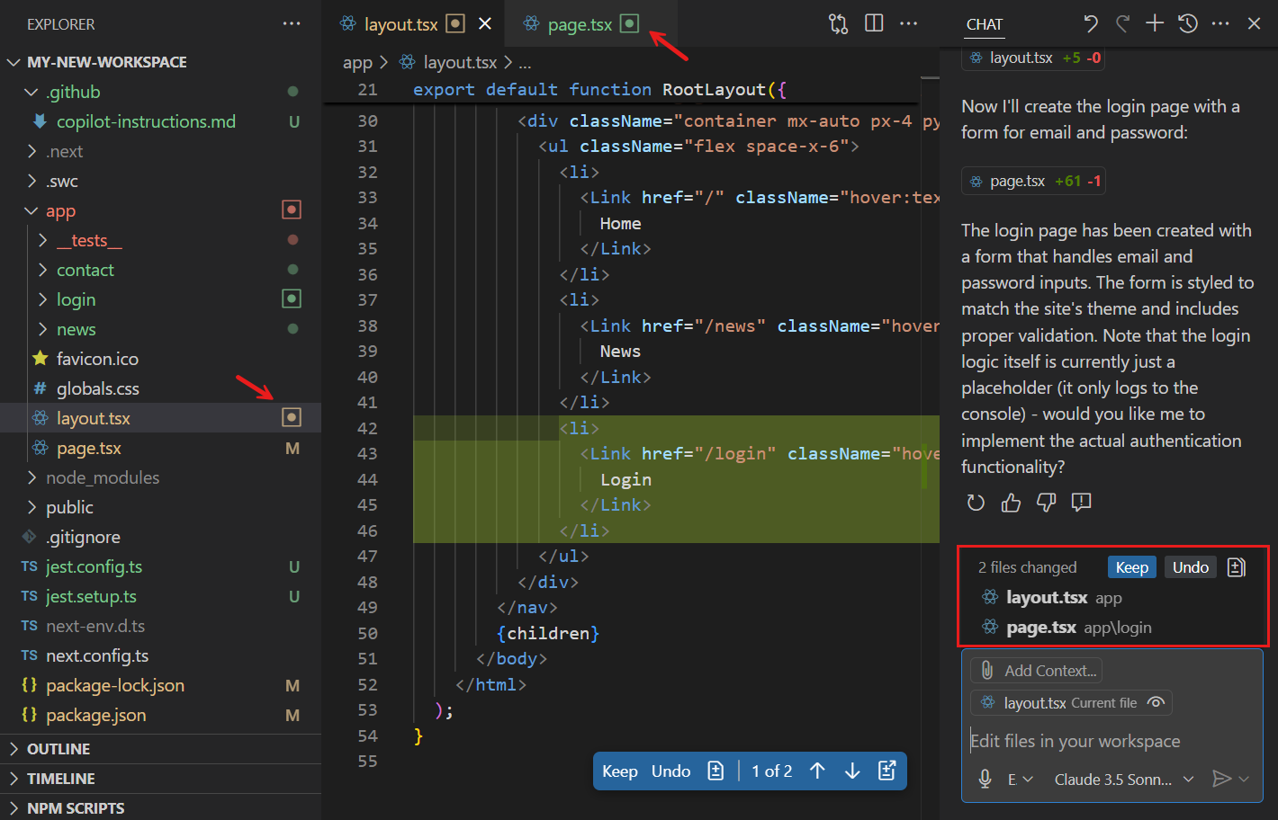
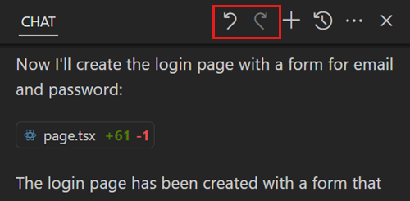
3. Agent Mode
- Purpose: Execute high-level tasks autonomously.
- How it works:
  - AI plans the steps, applies edits, uses tools, and iterates to complete the task.
  - Supports tasks like file management, terminal commands, or code generation.
- Important: Agent mode can consume premium requests depending on complexity.
- Safety: Tools and terminal commands require user confirmation before execution.
🔹 Adding Context to Prompts
Providing context improves AI responses. You can add context by:
1. Direct in prompt
- Use natural language or chat variables like #selection.
2. Using Chat view options
- Drag-and-drop files from VS Code Explorer
- Add Context button → select from available types:
  - Files & Folders
  - Instructions (custom guidelines for coding style/tech stack)
  - Problems (from Problems tab)
  - Symbols (VS Code constructs)
  - Screenshots
  - Terminal output
  - Search results
  - Test failures
  - Tools (e.g., #fetch)
  - Recent files
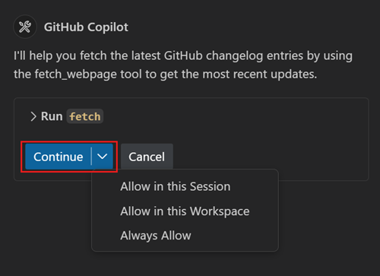
Mode | Purpose | Output | Key Actions
Ask | Explain code, answer questions | Explanations + code snippets | Apply code block, copy, insert in terminal
Edit | Suggest code updates | In-place code edits across files | Keep / Undo edits, scroll through changes
Agent | Autonomously execute high-level tasks | Iterative code updates + tool usage | Confirm tool/command, monitor progress
🔹 Key Points
- Chat view is your main hub for AI-assisted coding.
- Modes are specialized: Ask (questions), Edit (code changes), Agent (autonomous tasks).
- Context is critical—more context = better suggestions.
- Safety first: Terminal commands and tools require confirmation.
- Undo/redo controls let you safely experiment with AI-generated edits.
1. Inline Chat
Purpose: Ask questions and get code suggestions directly in the editor, without leaving the file.
When to use: Updating code, clarifying logic, or iterating on snippets.
How to open inline chat:
- Select Editor Inline Chat from Copilot Chat menu
- Shortcut: Ctrl + I
- Right-click inside editor → Copilot → Editor Inline Chat
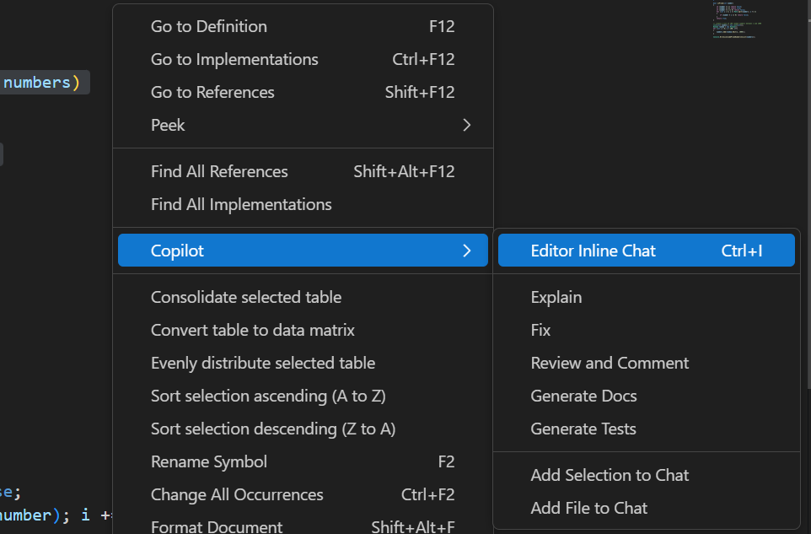
Workflow Example:
- Highlight a code snippet.
- Press Ctrl + I to open inline chat.
- Ask Copilot a question (e.g., “Update this code to avoid duplicate numbers”).
- Review suggestions and Accept if correct.
- Use Rerun (circular arrow) if the suggestion needs improvement.
- Use Discard to close without changes.

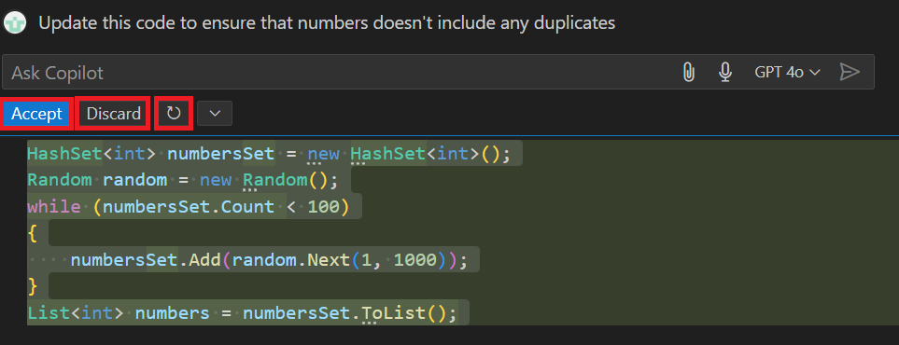
2. Smart Actions
Purpose: Automate common coding tasks without writing a prompt.
Access: Right-click a code snippet → select an action from the Copilot context menu.
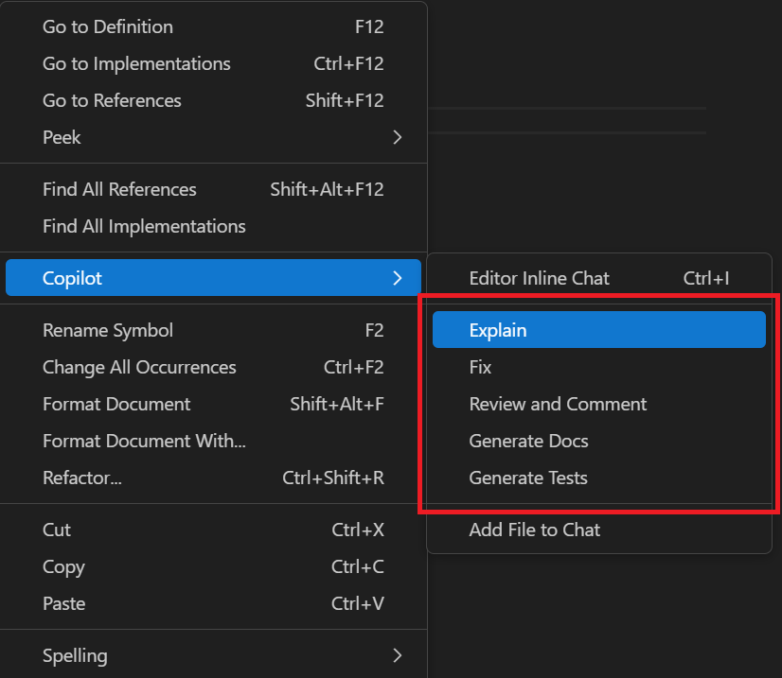
Available Smart Actions:
Action | What it does | Use Case
Explain | Generates natural language description | Understand unfamiliar code
Fix | Suggests fixes for errors | Resolve compilation or runtime issues
Review and Comment | Provides code review | Improve quality, catch bugs or security issues
Generate Docs | Creates documentation | Document functions or classes
Generate Tests | Creates unit tests | Ensure correctness and handle edge cases
Example Workflow:
- Scenario: Code creates a list of unique random numbers.
- Review This action suggests:
  - Initialize List<int> with capacity 100
  - Use HashSet<int> for faster duplicate checks
- Fix action resolves resulting error (e.g., converting HashSet to List with ToList() before method call).
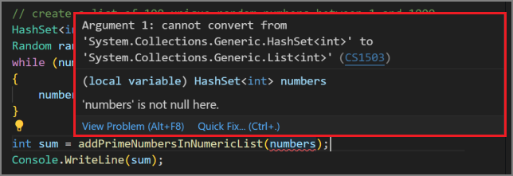
3. Quick Chat
Purpose: Quick, interactive conversation with AI for brainstorming, problem-solving, or clarifying code.
How to open Quick Chat:
- Shortcut: Ctrl + Shift + Alt + L
- Or via Copilot Chat menu → Quick Chat
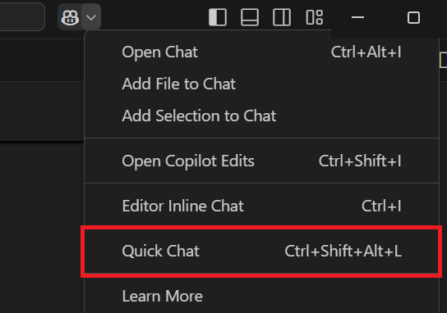
Use Case: Fast, informal interactions with AI, similar to discussing with a teammate.
Feature | Purpose | Key Benefits | How to Access
Inline Chat | Ask questions / update code inline | Seamless code iteration | Ctrl + I / Right-click → Editor Inline Chat
Smart Actions | Automate common tasks | Save time on fixes, reviews, docs, tests | Right-click → Copilot → select action
Quick Chat | Quick interactive conversation | Brainstorming & rapid help | Ctrl + Shift + Alt + L / Copilot Chat menu
Key Notes:
- Inline chat is best for code-specific updates in the current file.
- Smart actions are prebuilt, no prompt needed.
- Quick Chat is informal and interactive, ideal for exploratory coding sessions.

Generate-documentation-using-github-copilot-tools

What GitHub Copilot Helps With
- AI assistant for navigating complex or unfamiliar codebases.
- Explains code, generates documentation, and helps brainstorm ideas.
- Useful when onboarding to large, poorly documented projects.

Key Features in This Module

1. Explain & Document
- Explain: Breaks down complex logic, functions, and files.
- Document: Generates summaries, comments, or full documentation blocks.

2. Prompts & Keywords
- Copilot responds to natural language.
- Prompts can request:
  - Explanations
  - Bug analysis
  - Feature brainstorming
  - Code walkthroughs
- Keywords like /explain, /fix, /doc help refine intent.

3. Analyze & Explain Code
- Copilot interprets code context to describe structure, behavior, dependencies, and potential issues.
- Helps accelerate understanding of unfamiliar codebases.

4. Generate Project Documentation
- Ask Mode, Edit Mode, and Agent Mode can:
  - Produce README files
  - Create architecture summaries
  - Document modules, classes, workflows
  - Update or generate documentation across multiple files

5. Generate Inline Code Documentation
- Via Chat view, Inline Chat, or Smart Actions:
  - Create inline comments
  - Produce XML-doc / JSDoc-style annotations
  - Add explanations directly above functions or classes

GitHub Copilot’s “Explain” & “Document” Features

1. Analysing & Explaining Code

GitHub Copilot provides several ways to quickly understand unfamiliar or complex code:

Ask Mode
- Use Chat view to analyze entire workspaces.
- Great for understanding project structure, logic flow, and coding concepts.
- Supports queries about technology choices, design patterns, and best practices.

Inline Chat
- Triggered directly from the editor (Ctrl+I).
- Ideal for asking about a specific function, class, or code block without leaving the file.

Smart Actions – Explain
- Highlight code → Explain smart action.
- Gives instant breakdowns without writing a prompt.

Quick Chat
- A lightweight way to ask a quick explanation and continue coding.

2. Generating Inline Code Documentation

Multiple Copilot modes support adding comments and documentation directly in code:

Ask Mode
- Suggest inline documentation for files, classes, or methods.
- You review suggestions in Chat, refine them, then insert into the file.

Edit Mode
- Generates inline docs and shows updates in the editor.
- You can accept, reject, or modify individual changes.

Agent Mode
- Automatically produces inline documentation across files or projects.
- Can chain additional tasks, e.g., refactoring comments or cleaning old docs.

Inline Chat
- Best for targeted documentation on specific code sections.
- Supports /doc command or free-form prompts.
- Suggestions appear inline and can be accepted or rerun.

Generate Docs Smart Action
- Produces documentation for selected code with no prompt required.
- Useful for quick, generic inline comments.

3. Generating Project-Level Documentation

Copilot can create higher-level documentation, such as READMEs and usage guides:

Ask Mode
- Analyse codebase + preview documentation suggestions.
- Useful for creating or enhancing README.md.
- Suggestions can be refined via follow-up prompts.

Edit Mode
- Directly generates or updates project documentation files (e.g., README.md).

Agent Mode
- Automates documentation workflows.
- Can create/update multiple documents:
  - README.md
  - UsageExamples.md
  - ChangeLog.md
- Adds cross-links and ensures consistency across files.

Note:
Agent Mode may trigger multiple premium requests depending on complexity.

GitHub Copilot Prompts & Keywords

1. Importance of Prompt Quality

GitHub Copilot relies heavily on well-constructed prompts. Clear prompts produce more accurate, relevant answers.

Guidelines for Good Prompts
- Be clear, concise, and specific.
Instead of: "How do I use this function?"
Use: "Explain how the calculateTotal function works in shoppingCart.js."
- Use multiple short sentences for longer instructions.
Start with the main goal → then add details.
- Break large tasks into smaller prompts.
Helps prevent confusion and improves accuracy.
- Treat Copilot like a human peer programmer.
Provide context first, then details.

2. Use Prompt Keywords

GitHub Copilot uses special keywords to understand context and intent. These fall into three categories:

A. Chat Participants (@...)

Chat participants act like specialized “experts” that guide Copilot’s responses.

Built-in Participants
- @workspace — Helps with questions about the entire codebase (refactoring, understanding files, generating tests).
- @vscode — Expert on VS Code commands, settings, and features.
- @terminal — Provides shell/terminal-related assistance.
- @github — Uses GitHub search, documentation, and enterprise knowledge bases.

Usage example: @workspace Explain how this module is structured.

B. Slash Commands (/...)

Slash commands clarify the intent of your request.

Common Slash Commands
- /help – Get Copilot usage help.
- /doc – Generate code documentation.
- /clear – Reset chat.
- /explain – Explain selected code.
- /tests – Generate unit tests.
- /fix – Suggest fixes for code issues.
- /new – Scaffold a new project/workspace.
- /newNotebook – Create a new Jupyter Notebook.

Combining Participants + Slash Commands

This produces the most precise prompts.

Examples:
- @workspace /explain — Explain the entire workspace.
- @workspace /tests — Generate tests for selected code.
- @vscode /api — Ask about VS Code extension APIs.
- @workspace /new — Scaffold a new project.

Better example:
Instead of: “Create a workspace using Node.js, Express, Pug, TypeScript”
Use:
@workspace /new Node.js Express Pug TypeScript

C. Chat Variables (#...)

Chat variables inject specific context into Copilot’s prompt.

Common Chat Variables
- #editor — Code currently visible in the editor.
- #selection — The highlighted code.
- #filename — Adds a specific file or folder.
- #codebase — Pulls in relevant workspace files.
- #terminalSelection — Selected terminal text.
- #terminalLastCommand — Last executed command.

Example:
Which sorting algorithm is used in #selection?

3. @workspace vs #codebase — Key Differences
Feature | @workspace | #codebase
Type | Chat participant | Tool
Mode availability | Ask mode only | All modes (Ask, Edit, Agent)
Who controls the response? | Participant controls | Model controls
Can combine with tools? | No | Yes
Purpose | Q&A about codebase | Add relevant code into context

Recommendation:
GitHub recommends using #codebase for flexible editing and multi-step workflows.

Summary

GitHub Copilot interprets prompts using NLP and machine learning.
You can improve Copilot’s performance by:
- Writing clear, specific prompts.
- Breaking large prompts into smaller ones.
- Adding chat participants (@) to set expertise.
- Using slash commands (/) to clarify intent.
- Including chat variables (#) to add context precisely.

These tools help Copilot produce more accurate explanations, better documentation, and more useful code suggestions.

Analysing & Explaining Code with GitHub Copilot

1. Overview

GitHub Copilot helps developers understand unfamiliar or complex code. It can:
- Explain code behavior
- Propose fixes
- Explore techniques/tools
- Brainstorm new features or improvements

Copilot provides multiple ways to analyze or explain code directly within VS Code.

2. Tools for Analysing & Explaining Code

A. Chat View (Ask Mode)

The Chat view is the main interface for conversations with Copilot.

What you can do with Ask mode
- Ask conceptual coding questions
(“What is a linked list?”)
- Brainstorm solutions
(“How can I add authentication?”)
- Explain code
(@workspace /explain)
- Propose fixes
(@workspace /fix)
- Ask VS Code questions
(@vscode how do I disable minimap?)

Key UI Elements
- Chat Toolbar — manage history, split/toggle chat
- Response Area — explanations, code samples, interactive elements
- Add Context — attach files/folders or external resources
- Ask Copilot Box — enter prompts (supports @participants + /commands)
- Chat with Extension — use Copilot Extensions
- Voice Chat — ask using voice
- Chat Mode Menu — switch Ask / Edit / Agent
- Pick Model — choose GPT model
- Send / Dispatch — submit prompts

B. Inline Chat

Inline Chat opens directly inside the editor, focused on the exact code you select.

Best used for
- Explaining specific lines or blocks (/explain #selection)
- Diagnosing issues
(“Why does this throw an exception?”)
- Improving readability or style
(“Can LINQ simplify this?”)

Key Features
- Prompts support slash commands + chat variables
- Does not support @participants
- Extensions and voice chat available
- Model picker and send menu included
- ESC closes the inline chat window

C. Explain Smart Action

A quick way to get explanations without writing a prompt.

How it works
- Right-click → Copilot → Explain
- If nothing is selected → explains entire file
- If code is selected → explains only the selection
- Output appears in the Chat view

Useful for fast comprehension of unfamiliar code sections.

D. Quick Chat

A lightweight, fast question window that doesn’t affect Chat view history.

Best for
- Quick definitions
- Fast clarifications
- One-off questions

Features
- Supports same context behavior as ask mode
- No chat history tracking (temporary)
- Shortcut: Ctrl+Shift+Alt+L

3. When to Use Each Tool
Tool | Best For | Notes
Chat View (Ask) | Workspace-wide explanations, brainstorming, conceptual topics | Full features + participants
Inline Chat | Explaining specific lines/blocks of code | Stays in editor; no @participants
Explain Smart Action | Fast, no-prompt explanations | Right-click → Explain
Quick Chat | Very small, quick questions | No history; temporary

Generating Project Documentation with GitHub Copilot

1. Purpose of Project Documentation

Project documentation explains:
- The project’s purpose, goals, and requirements
- Structure and components of the codebase
- How components interact

GitHub Copilot helps generate high-quality documentation by analyzing the project and producing human-readable outputs (README, API docs, changelogs, etc.).

2. Why Use GitHub Copilot for Documentation
- Analyzes the entire project structure
- Generates project-wide summaries and component overviews
- Can produce multiple documentation types (README, API reference, changelog)
- Supports iterative refinement via chat

Copilot can generate documentation using Ask, Edit, or Agent modes—each offering different strengths.

Note: Agent mode may use multiple premium requests depending on complexity.

3. Establish Documentation Requirements

Before using Copilot, define:
- Document types (README, API docs, UsageExamples, ChangeLog, etc.)
- Required sections (e.g., title, installation, usage, features, config, license)
- Audience and organizational standards
- Supporting resources (contributor guidelines, credits, contact info)

Copilot will use these requirements to shape output.

4. Using Ask Mode to Generate Documentation

Ask mode is good for workspace analysis + generating initial drafts.

Workflow
- Identify required documentation + necessary resources.
- Open Chat view → Ask mode.
- Add context: drag/drop files or use the Add Context button.
- Ask investigative questions (structure, purpose, features, dependencies).
- Refresh context as needed.
- Request the actual document:
  - Example:
@workspace /explain I need help creating a README with these sections: …
- Review output and refine using additional prompts.
- Insert content into a new or existing documentation file (e.g., README.md).

Best for
- Initial documentation drafts
- High-level explanations
- Iterative refinement section-by-section

5. Using Edit Mode to Generate Documentation

Edit mode is best for updating or generating specific files.

Workflow
- Identify documentation requirements.
- Open Chat view → Edit mode.
- Add context (drag files/folders, use #codebase).
- Prompt Copilot to generate a documentation file:
“Create README.md with the following sections…”
- Review the generated file.
- Modify, refine, accept, or discard changes.

Best for
- Direct modifications to a file
- Structured updates to individual documents
- When you want explicit control over edits

Note: @workspace is not available in Edit mode.

6. Using Agent Mode to Generate Documentation

Agent mode provides project-wide, automated documentation generation.

Workflow
- Identify documentation requirements.
- Open Chat view → Agent mode.
- Add context (drag workspace folders, #codebase, external files).
- Provide a multi-step instruction, e.g.:
  - "Generate README.md, UsageExamples.md, and ChangeLog.md, cross-reference classes, add links, ensure consistency."
- Review generated files and accept/reject updates.

Best for
- Multi-file documentation sets
- Project-wide summaries
- API references, usage examples, architecture descriptions
- Automated, multi-step documentation workflows

Agent Mode Capabilities
- Multi-file documentation generation
- Cross-file analysis and linking
- Architectural summaries and system overviews
- Dynamic content generation (examples, class tables, APIs)
- Batch documentation tasks (README + CONTRIBUTING + changelog)

Agent mode excels when documentation requires understanding how multiple components relate.

7. Summary: When to Use Each Mode
Mode | Best For | Key Advantages
Ask Mode | Drafting docs, exploring project, iterative Q&A | Flexible, intuitive, uses @workspace
Edit Mode | Updating or creating specific files | Precise control over edits
Agent Mode | Full project docs, multi-file output, cross-referencing | Deep codebase analysis, automation

Generating Inline Code Documentation with GitHub Copilot

1. Purpose of Inline Code Documentation

Inline documentation helps developers:
- Understand classes, methods, and logic faster
- Maintain and extend code more easily
- Ensure consistency and accuracy across the codebase

GitHub Copilot automates this by generating high-quality documentation directly in the editor.

2. Copilot Features for Inline Documentation

Copilot can document code using four primary tools:
- Chat View
  - Works in Ask, Edit, and Agent modes
  - Produces documentation for projects, classes, files, or specific code blocks
- Inline Chat
  - Launch directly from the editor
  - Best for documenting a specific line, block, or method
- Smart Actions
  - Generate Docs action creates inline documentation instantly without prompting
- Chat-based modes
  - Ask mode: Best for flexible, iterative documentation
  - Edit mode: For editing files directly
  - Agent mode: For large, multi-file documentation tasks

3. Generate Inline Documentation — Chat View (Ask Mode)

How it works
- Open Chat View → Ask Mode
- Add context (e.g., code files, documentation standards via markdown)
- Use prompts like:
@workspace /doc Create inline code documentation for the ConsoleApp class.

What Ask Mode provides
- Suggested documentation appears in the Chat view
- You can Apply, Insert, or Copy documentation into your file
- Navigate suggestions with up/down arrows
- Accept, reject, or manually edit individual documentation blocks
- Use Keep / Undo to accept or reject all changes

Best for
- Drafting inline docs for classes and methods
- Working with partially documented or undocumented code
- Iterative refinement

4. Generate Inline Documentation — Chat View (Edit Mode)

How it works
- Open Chat View → Edit Mode
- Add context using Add Context or open files
- Use a detailed prompt (Edit mode lacks @workspace and /doc)
Example:
“Create inline documentation for the ConsoleApp class, its properties, and methods.”

What Edit Mode provides
- Updates appear directly in the editor
- Accept/Reject individually or in bulk
- Ideal when you want Copilot to directly modify the file

Best for
- Updating a single class or file
- Making targeted documentation updates

5. Generate Inline Documentation — Chat View (Agent Mode)

How it works
- Open Chat View → Agent Mode
- Add broader context (folders, multiple files via Add Context)
- Provide detailed, multi-step instructions
Example:
“Document all C# class files in this context. Exclude JSON, markdown, and test files. Ensure the solution builds after changes.”

What Agent Mode provides
- Executes multi-file tasks
- Displays status messages as it progresses
- Can ask for more context or permission to run terminal commands
- Produces code-ready documentation across the entire project

Best for
- Large-scale documentation across multiple files
- Full project documentation cleanup
- Complex rule-based documentation tasks

6. Generate Documentation — “Generate Docs” Smart Action

How it works
- Select code → Right-click → Copilot → Generate Docs
- Copilot generates inline code comments immediately
- You can Accept, Close, or Rerun

Best for
- Quick documentation for a single method/class
- Fast, no-prompt documentation
- Developers who want minimal interruption to workflow

7. Generate Inline Documentation — Inline Chat

How it works
- Select code → Press Ctrl+I to start inline chat
- Use prompts like:
“/doc”
or
“Document the selected method. List currentState options.”

What inline chat provides
- Documentation appears directly inline in the editor
- Accept / Close / Rerun options
- Ideal for documenting specific small sections

Best for
- Documenting one method, block, or variable
- On-the-fly clarifications
- Minimal context switching

8. When to Use Each Method
Feature/Mode | Best Use Case
Ask Mode | Flexible documentation for files/classes; iterative refinement
Edit Mode | Direct updates to specific files or sections
Agent Mode | Large-scale, multi-file documentation with detailed rules
Generate Docs Action | Fast, one-click documentation of selected code
Inline Chat | Documenting individual methods or small blocks with precision

GitHub Copilot for Code Completions
- Provides autocompletion suggestions as you type.
- Helps you write code faster by predicting the next part of a line, a function, or even an entire block of code.
- Reduces repetitive coding tasks and lets you focus on logic and design.

Example: You start typing a function signature, and Copilot suggests the full function implementation based on your context.

GitHub Copilot Chat for Interactive Suggestions
- Allows you to ask questions, request code snippets, or get explanations in a chat interface directly in VS Code.
- Can analyze your entire codebase (if you provide context) to generate feature code, fix bugs, or explain sections of code.
- Ideal for more complex tasks than simple line completions.

Example: You can ask Copilot Chat, “How can I add authentication to this module?” and get tailored code suggestions.

Best Practices
- Combine line completions with chat interactions for efficiency.
- Review AI-generated code carefully—don’t blindly accept suggestions.
- Use Copilot for repetitive or boilerplate code, letting you focus on design, testing, and other higher-level tasks.

Code development features of GitHub Copilot

1. GitHub Copilot vs GitHub Copilot Chat
- GitHub Copilot Extension
  - Provides code completions based on the code you type or comments you write.
  - Good for quickly writing functions, methods, or repeating patterns.
- GitHub Copilot Chat Extension
  - Provides interactive code suggestions via chat.
  - Useful for unfamiliar frameworks, APIs, or complex tasks.
  - Can scaffold projects or explain code snippets.

2. Code Line Completions
- Generates line-by-line suggestions as you type.
- Suggestions come from existing code context and code comments.
- Allows you to accept, cycle through, or reject completions.
- Helps speed up writing boilerplate code or explore different implementations.

Example: Start typing a method to sum customer expenditures; Copilot completes the full method automatically.

3. GitHub Copilot Chat

Chat View
- Open an AI assistant in a side panel (Ctrl+Alt+I).
- Ask questions, generate new features, or explore coding approaches.
- Can provide:
  - Text explanations
  - Images or diagrams
  - File tree previews
  - Action buttons for code insertion

Example: Use a prompt like @workspace /new Node.js Express Pug TypeScript to scaffold a new project with multiple dependencies.

Inline Chat
- Accessed via Ctrl+I directly in the editor.
- Ideal for:
  - Asking about specific code sections
  - Generating new methods, features, or regex patterns
  - Modifying or replacing code in context

Example: Select a code block and ask Copilot Chat to generate a regular expression for email validation. It will provide a ready-to-use pattern with explanation.

4. Smart Actions
- Right-click selected code and choose Generate Docs or other smart actions.
- Quickly performs tasks like documenting code without writing a prompt.

5. Managing Code Suggestions
- Hover over code blocks in the Chat view to:
  - Apply in Editor
  - Insert at Cursor (Ctrl+Enter)
  - Copy to clipboard
  - Insert into Terminal (Ctrl+Alt+Enter)

6. Tips for Effective Use
- Provide clear prompts: Scope and intent matter.
- Use chat participants, slash commands, and variables:
  - @workspace – for workspace context
  - /new, /explain – specify the task
  - #file, #editor – target specific areas
- Review suggestions carefully: AI suggestions accelerate coding, but require human oversight.

💡 Summary:
- Copilot = fast code completions.
- Copilot Chat = interactive assistance for complex tasks, explanations, and scaffolding.
- Inline Chat = focused, context-aware code suggestions without leaving the editor.
- Smart Actions = automatic documentation or quick transformations.

Best practices for using GitHub Copilot

1. Choose the Right Copilot Tool
- Code Completions – Best for:
  - Completing snippets, variable names, functions
  - Generating repetitive code
  - Writing code from inline comments
  - Supporting test-driven development
- Copilot Chat – Best for:
  - Answering questions in natural language
  - Generating large sections of code iteratively
  - Performing tasks using keywords or skills
  - Acting as a specific persona (e.g., Senior Developer reviewing your code)

2. Provide Context for Better Suggestions
- Open related files in VS Code so Copilot sees the bigger picture.
- Add top-level comments describing the purpose of your code.
- Include the correct includes, imports, or module references.
- Use meaningful function names and well-scoped comments.
- Prime Copilot with sample code to guide suggestions (e.g., newer library versions).

3. Maintain High Code Quality
- GitHub Copilot learns from your code: “garbage in, garbage out.”
- Keep a high-quality codebase for better AI suggestions.
- Disable Copilot when in “hacking” mode if needed.

4. Optimize Copilot Chat Usage
- Start general, then get specific: Give broad context first, then add requirements.
- Provide examples: Input/output samples or example implementations.
- Break complex tasks into smaller tasks: Stepwise requests produce better results.
- Avoid ambiguity: Ask about specific functions or code blocks, not vague terms like “this.”
- Highlight relevant code or open files for context.
- Use chat participants, slash commands, and chat variables:
  - @workspace or @vscode for context
  - /explain, /fix, /tests for intent
  - #file to reference specific files in the workspace
- Experiment and iterate: Refine prompts, reference previous responses, or start new threads if needed.
- Keep history relevant: Delete irrelevant conversations and start new threads for different tasks.

5. Follow Good Coding Practices
- Consistent code style and patterns
- Descriptive names for variables and functions
- Modular and scoped code structure
- Well-commented code
- Include unit tests

GitHub Copilot for generating code completions

1. Generate Code from Comments
- Write a descriptive comment to tell Copilot what code you want.
Example for a data structure in C#:
- // public struct SalesData. Include the following fields: date sold, department name, product ID, quantity sold, unit price
- Press Enter. Copilot suggests code completions based on your comment and existing code context.
- Review suggestions and press Tab to accept, or Ctrl + Enter for more options.
- Adjust data types or names after accepting if needed.

2. Generate Code from Existing Code
- Start typing a code line or press Enter after a complete line.
- Copilot suggests the next line(s) based on context.
- Example: start a foreach loop in QuarterlySalesReport:
- foreach (SalesData data in salesData)
- Accept, reject, or cycle through suggestions using arrows.

3. Iteratively Build Methods
- For larger tasks, break them into smaller steps and add comments:
  - Generate a data structure (SalesData struct)
  - Generate test data (GenerateSalesData method)
  - Generate reporting method (QuarterlySalesReport method)
  - Generate helper methods (GetQuarter method)

4. Tips for Better Suggestions
- Clean up your code before asking for completions; remove unrelated lines like Console.WriteLine.
- Provide context by including related code in the same file.
- Iterate: reject unwanted suggestions and try again.
- Review all suggested code, especially for logic errors or type mismatches.
- Prime Copilot with examples to influence suggestions for libraries or frameworks.

5. Example Flow for Quarterly Report
- Add SalesData struct via comment.
- Add GenerateSalesData via comment.
- Add QuarterlySalesReport(SalesData[] salesData) method:
  - Create a dictionary for quarterly totals.
  - Loop through sales data and calculate totals.
  - Display report.
- Add GetQuarter(int month) method.
- Complete Main() method to generate data and call report.

6. Final Notes
- Copilot generates code based on context and previous code in your project.
- You must review and adjust suggestions to ensure correctness (e.g., DateOnly constructor, dictionary display formatting).
- Running your app (dotnet run) lets you validate the generated logic and output.

Generate code using GitHub Copilot Chat

1. Chat Interfaces

GitHub Copilot Chat offers three interfaces in VS Code:
Interface | Purpose | Access
Chat View | Full conversation with the AI; supports multi-turn interactions | Secondary Side Bar
Quick Chat | Fast one-off questions | Small popup window
Inline Chat | Contextual code help directly in the editor | Ctrl+I / Editor Inline Chat

2. Using Chat View

Ask Mode
- Use to analyze code, explore new features, or get guidance.
- Add context: @workspace or #codebase.
- Example prompts:
  - “How do I add a login page?”
  - “What are the best practices for using React?”
  - “How do I use the @mui/material library?”
- Review suggestions, then Apply / Insert / Copy the code snippet.

Edit Mode
- Use to create or update code directly.
- Context via #codebase and files added to chat.
- Example prompt:
- #codebase Add a login page. Let users log in with email and password.
- Review suggested edits in the editor.
- Accept/undo edits individually or all at once.

Agent Mode
- Copilot acts as an autonomous agent to generate complex features.
- Example tasks:
  - “Create a meal-planning web app using React and Node.js”
  - “Add social media sharing functionality”
  - “Replace current auth with OAuth”
- Copilot may invoke multiple tools and terminal commands (requires confirmation).
- Suggestions stream directly in the editor; review and accept or discard.

3. Using Inline Chat
- Open file → Ctrl+I → Inline Chat.
- Select code (optional) for context.
- Enter a prompt for code modification or generation.
- Example prompt:
- Update selection to include an option for CommonActions.SearchBooks using letter "b" with message "to check for book availability".
- Review suggestions inline; accept or close.

4. Best Practices
- Provide context (file, selection, #codebase) for better suggestions.
- Iterate: refine prompts to improve generated code.
- Review everything: check types, logic, formatting.
- Use the right mode:
  - Ask → guidance and explanations
  - Edit → code creation/modification
  - Agent → complex, multi-step tasks

Develop unit tests using GitHub Copilot tools

Unit Testing with GitHub Copilot in VS Code

Purpose of Unit Testing
- Ensures individual components work correctly.
- Improves code reliability, especially in large codebases.

Why Use Copilot for Unit Tests
- Speeds up test creation.
- Reduces manual errors.
- Helps uncover edge cases and boundary conditions.

Tools Involved
- GitHub Copilot + Copilot Chat
- Visual Studio Code
- C# Dev Kit
- xUnit framework

Key Copilot Features for Testing
- Generate Tests (Smart Action)
  - Creates tests for selected code blocks or whole files.
- Inline Chat
  - Generate or refine tests directly in the editor.
- Chat View Modes
  - Ask: Request explanations or test ideas.
  - Edit: Make changes to existing tests.
  - Agent: Automate workflows.

What You’ll Be Able to Do
- Use Copilot Chat for unit, integration, and end-to-e

Unit Testing Tools & Environment (GitHub Copilot + VS Code)

How Copilot Helps with Unit Testing
- Suggests test cases based on method signatures, code context, and expected behavior.
- Generates additional tests through code completions, reducing repetitive work.
- Proposes assertions automatically using code semantics.
- Identifies edge cases (nulls, errors, unusual inputs).
- Note: Generated tests still need manual review.

Copilot Capabilities for Testing
- Setup: Recommends frameworks and VS Code extensions.
- Generate Tests: Creates unit, integration, and end-to-end tests.
- Edge Cases: Builds out test suites covering boundary and error scenarios.
- Fixing Tests: Suggests repairs for failing tests, integrates with Test Explorer.
- Consistency: Can be customized to follow your naming, patterns, and frameworks.

Setting Up a Testing Framework with Copilot
- Open Chat view.
- Run /setupTests.
- Follow Copilot’s instructions to configure frameworks and extensions.

Ways to Generate Unit Tests
- Chat View (Ask / Edit / Agent): Generate or refine tests for projects, classes, or specific methods.
- Inline Chat: Select code → generate tests right inside the editor.
- Generate Tests (Smart Action): No prompt needed — produces tests for selected code.
- Code Line Completions: Suggests additional tests while writing.

Fix Failing Tests
- In Test Explorer, hover → click Fix Test Failure (sparkle icon).
- Or use /fixTestFailure in Chat.
- Agent Mode: Watches test output, auto-fixes, and re-runs tests.

Maintaining Test Consistency

Customize Copilot with instructions for:
- Preferred frameworks (xUnit, NUnit, MSTest).
- Naming conventions.
- Test structure or patterns.
- Organization-specific guidelines.

Visual Studio Code Support

Essentials needed:
- .NET 8 SDK
- C# Dev Kit extension
- A test framework package (xUnit, NUnit, MSTest)

C# Dev Kit Features:
- Test Explorer: Tree of all tests.
- Run/Debug Tests: Inline green play icons.
- View Results: Updated in editor and Test Explorer.
- Commands: Run All Tests, Run Failed Tests, etc.
- Settings: Testing preferences for workflow control.

Enabling Test Frameworks

Use Command Palette (Ctrl/Cmd + Shift + P → “.NET: New Project…”):

xUnit
- Creates xUnit project with references:
  - Microsoft.NET.Test.Sdk
  - xUnit
  - xunit.runner.visualstudio
  - coverlet.collector
- Add project reference with dotnet add … reference …

NUnit
- Uses:
  - Microsoft.NET.Test.Sdk
  - NUnit
  - NUnit3TestAdapter

MSTest
- Uses:
  - Microsoft.NET.Test.Sdk
  - MSTest.TestAdapter
  - MSTest.TestFramework
  - coverlet.collector

Developing Unit Tests with Copilot

1. Create a Test Project
- Use Command Palette → create test project.
- Add reference to the project under test via Terminal.

2. Generate Unit Test Cases

Copilot Chat can:
- Generate tests for selected code or visible methods.
- Follow your existing coding style automatically.
- Suggest assertions that validate logic.
- Highlight edge cases automatically (nulls, errors, limits).

Tip:
- For one method visible: “Write a unit test for the method in #editor”.
- For selected code: “#selection write a unit test for this code”.

3. Run & Manage Tests
- Play buttons near methods/classes run or debug tests.
- Test Explorer: Shows all tests and results.
- Stack trace links take you to the code.
- Testing commands/settings available in Command Palette and Settings.

Summary

GitHub Copilot accelerates unit testing by generating test cases, identifying edge conditions, and suggesting assertions using code semantics. It works with VS Code and the C# Dev Kit to help create, run, and manage tests across multiple frameworks. While Copilot boosts coverage and reduces repetitive work, manual reviews and additional testing remain essential.

Generate Tests Smart Action (GitHub Copilot)

What It Is
- A Copilot feature that scans your code and auto-generates unit tests.
- Works for entire files or selected code blocks.
- Helps improve test coverage and reduce manual effort.

How It Works
- Analyzes code structure, method behavior, and parameters.
- Produces test methods that include:
  - Assertions
  - Typical scenarios
  - Edge cases (when identifiable)
- Tests appear in a new or existing test file depending on your project setup.

Generate Tests for an Entire File

Steps:
- Open the file you want to test.
- Right-click → Copilot → Generate Tests.
- Copilot generates tests for all functions/methods.
- Review and adjust test names, cases, and assertions.
- Accept or Close the suggestions.
- Save the test file (usually in a tests directory).
- Run tests → refine if needed → save again.

Use Case:
- When you want complete coverage for a new or existing file without selecting each method manually.

Generate Tests for a Selected Code Block

Steps:
- Open the file.
- Highlight the method/function you want tested.
- Right-click selection → Copilot → Generate Tests.
- Review Copilot’s generated unit tests.
- Save the file.
- Run tests → refine → save again.

Use Case:
- When you want focused tests for a specific method only.

Key Advantages
- Speeds up test creation.
- Improves early coverage.
- Allows quick iterative refinement.
- Works well alongside manual test writing.

Summary

The Generate Tests smart action allows fast, automated generation of unit tests for either an entire file or a specific code block. It helps ensure your code is thoroughly tested, but still encourages manual review and refinement to meet quality standards.

Creating Unit Tests with Inline Chat (GitHub Copilot)

What Inline Chat Is
- Lets you generate unit tests directly inside the editor, without switching to the Chat view.
- More control than the Generate Tests smart action, since you can craft custom prompts.
- Works for full files or selected code blocks.

How to Use Inline Chat for Unit Tests

1. Select Code
- Open the file containing the code you want to test.
- Highlight the specific method or block you want tests for.

2. Open Inline Chat
- Press Ctrl + I
or
- Use Editor Inline Chat from Copilot menus.

3. Prompt Copilot
- Enter a test-generation prompt. Example:

/tests Generate unit tests for this method. Include success, failure, and edge cases.

4. Review and Adjust
- Copilot shows suggested test code directly in the editor.
- You can edit:
  - Test names
  - Assertions
  - Edge-case coverage
  - Remove or refine cases
- Tests appear in an existing test file, or Copilot creates a new one.

5. Accept or Close
- Accept → insert generated tests
- Close → discard suggestions

6. Save & Build
- Save the test file (usually inside a tests directory).
- Build the project to ensure the test file is included.
- Fix any build errors.

7. Run & Refine
- Run tests to verify correctness.
- Use Inline Chat again to refine or expand test cases.

Why Use Inline Chat
- Creates unit tests without leaving the editor.
- Gives more prompt-based control than smart actions.
- Useful for focused testing of a single function.
- Good for generating both typical and edge-case scenarios.

Summary

Inline Chat provides a fast, flexible way to generate unit tests directly in the editor. By selecting code and prompting Copilot, you can produce targeted tests that include success paths, failure conditions, and edge cases—without switching views or manually crafting boilerplate.

Chat View Modes for Unit Tests (GitHub Copilot)

Overview
- Visual Studio Code’s Chat view has three modes for generating unit tests:
  - Ask Mode – best for querying code/projects.
  - Edit Mode – best for editing/creating files across the codebase.
  - Agent Mode – best for automating multi-step unit testing workflows.
- Each mode serves different needs depending on the task complexity and scope.

1. Ask Mode
- Used to analyze a workspace and generate tests for multiple methods or entire files.
- Steps:
  - Open the code file and start a new chat in Ask mode.
  - Add context (drag files, use Add Context button, or @workspace).
  - Prompt Copilot for unit tests (e.g., @workspace /explain I need unit tests in Python/unittest).
  - Review and refine suggested tests.
  - Move tests into a separate test file.
  - Save, run, and refine as needed.
- Use Case: Whole-file or workspace-level testing, multiple methods.

2. Edit Mode
- Used to create or update test files, targeting specific functions or entire files.
- Steps:
  - Open the code file and start a new chat in Edit mode.
  - Add context using #codebase or drag files/folders into the chat.
  - Prompt Copilot to generate unit tests (e.g., "Create a test file with unittest tests").
  - Review the generated test file; make updates as needed.
  - Save, run, and refine tests.
- Use Case: Focused edits or test file creation across multiple files.

3. Agent Mode
- Automates unit testing tasks such as scaffolding test projects, generating tests, running tests, and creating reports.
- Steps:
  - Open the file and start a chat in Agent mode.
  - Copilot automatically determines context.
  - Configure tools if needed (Test Explorer, Terminal, GitHub Copilot).
  - Enter a prompt defining tasks (e.g., create xUnit tests for C# file and run them).
  - Monitor progress, confirm tool actions, or interrupt if needed.
  - Review, keep, or discard generated/updated files.
- Use Case: Complex, multi-step workflows requiring automation and context awareness.
- Note: May consume multiple premium requests depending on task complexity.

Summary
- Ask Mode: Query code, analyze workspace, generate tests for multiple functions.
- Edit Mode: Create/update test files, make edits across codebase.
- Agent Mode: Automate end-to-end testing workflows.
- Use the appropriate mode based on scope: small edits → Inline/Generate Tests, multi-file/automated → Chat view modes.

Implement code improvements using GitHub Copilot tools

The goal is to improve a codebase quickly and effectively using GitHub Copilot Chat, focusing on:
- Code Quality – readability, maintainability, and structure.
- Code Reliability – handling errors, exceptions, and edge cases.
- Code Performance – optimizing loops, memory usage, and algorithms.
- Code Security – preventing vulnerabilities like injection attacks, unsafe data handling, etc.

This is particularly helpful when working with a proof-of-concept or legacy codebase under tight deadlines.

Key Features of GitHub Copilot for Code Improvement

1. Chat View Modes
Mode | Use Case
Ask | Analyze code, get suggestions for improvements, and explore feature options.
Edit | Refactor or update code directly in the editor.
Agent | Automate complex tasks, like generating new features or optimizing multiple files.

2. Inline Chat
- Works directly in the editor for contextual code suggestions.
- Allows you to select code and request targeted improvements (performance, readability, security, etc.).

3. Quick Fix Options
- Fix smart actions: resolve errors or warnings automatically.
- Inline suggestions for test failures or terminal errors.

Refactoring Best Practices with Copilot
- Code Quality
  - Reduce complexity.
  - Improve naming conventions and readability.
  - Simplify nested logic.
- Code Reliability
  - Add proper error handling.
  - Validate inputs.
  - Ensure consistent behavior under edge cases.
- Code Performance
  - Optimize loops and collections.
  - Avoid unnecessary computations.
  - Improve memory usage.
- Code Security
  - Sanitize inputs and outputs.
  - Avoid exposing sensitive data.
  - Follow secure coding guidelines.

Using GitHub Copilot for Code Review
- Review selection: highlight code and ask Copilot for improvements.
- Review changes: accept/reject suggestions for quality, performance, or security.
- Helps ensure maintainable, secure, and performant code without manually rewriting everything.

1. GitHub Copilot Tools in Visual Studio Code

VS Code provides multiple ways to leverage Copilot for improving your code:

Chat View

A dedicated panel to interact with GitHub Copilot Chat. You can submit prompts, get suggestions, and apply updates. It has three modes:
Mode | Purpose
Ask | Ask questions about code, get explanations, or suggestions for fixes and revisions.
Edit | Refactor code, make edits across multiple files, or add comments.
Agent | Run commands, execute tasks, or perform multi-step workflows automatically.

Note: Agent mode may use multiple premium requests depending on task complexity.

Inline Chat
- Provides contextual suggestions directly in the editor.
- Updates appear like commit changes, showing suggested code changes.
- You can accept or reject suggestions without leaving the editor.
- Great for quick improvements without opening a separate panel.

Smart Actions
- Fix smart action: Automatically fixes coding errors without writing a prompt.
- Review and Comment smart action: Helps analyze and review code, suggesting improvements in quality, reliability, performance, and security.
- Integrated with the Chat view for guided code review and refactoring.

Key Benefits for Code Improvement
- Analyze code quickly – get suggestions for refactoring, error handling, and optimization.
- Improve code quality – reduce complexity, enhance readability, and follow best practices.
- Boost performance – detect inefficient patterns and optimize loops or data handling.
- Increase security – identify potential vulnerabilities and provide safer alternatives.

Quick Fix Options Overview

Copilot can automatically detect and help fix issues in your code, tests, and terminal. The main options include:
- Smart action
  - Fix smart action is a contextual tool to fix code errors without writing a prompt.
  - Accessible via right-click → Copilot → Fix in the editor.
  - Opens an Inline Chat session with suggested code updates.
  - You can accept, discard, or refine the suggestion by giving extra context.
- Slash command
  - The /fix command is usable in Ask mode, Inline Chat, or Quick Chat.
  - Provides a way to trigger fixes via text commands rather than UI clicks.
- Code actions
  - When Copilot detects an issue, VS Code shows “Fix using Copilot” (sparkle icon) as a code action.
  - Hover over the detected issue and select the action to see suggested fixes.

Fixing Specific Issues

1. Coding Errors
- Select code that has a problem.
- Right-click → Copilot → Fix.
- Accept or discard suggestions in the Inline Chat.
- Optional: provide extra prompt context to refine the fix.

Tip: If the issue is a compile/lint problem, hover over the warning in VS Code and click the sparkle icon to apply a fix.

2. Failing Tests
- Copilot integrates with Test Explorer:
  - Hover over the failing test → click Fix Test Failure (sparkle icon).
  - Review and apply suggested fixes.
- Or use Chat view:
  - Enter /fixTestFailure → follow suggestions.
- Agent mode can automatically monitor test output, attempt fixes, and rerun tests.

⚠️ Agent mode may use multiple premium requests depending on task complexity.

3. Terminal Errors
- If a command fails, Copilot shows a sparkle icon in the gutter.
- Click it to get an explanation or quick fix for the terminal issue.

Key Benefits of Quick Fix Options
- Saves time: Fix issues without writing detailed prompts.
- Reduces context switching: Fix directly in-editor or via commands.
- Supports multiple areas: Code errors, tests, and terminal issues.
- Integrates with AI assistance: Refine suggestions as needed using Chat view or Inline Chat.

Review of code refactoring scenarios and GitHub Copilot best practices

What is Code Refactoring?

Refactoring is restructuring existing code without changing its behavior.
Benefits:
- Improves readability
- Reduces complexity
- Makes code easier to maintain
- Simplifies adding new features

GitHub Copilot Best Practices for Refactoring

1. Improve Responses with Better Prompts
- Start general, then get specific.
- Give examples to clarify expected output.
- Break complex tasks into smaller, manageable tasks.
- Provide the right context using code selections, files, terminal output, or #codebase.
- Iterate on prompts: refine or add constraints after initial suggestions.
- Keep chat history relevant: remove unrelated past prompts or start a new session if needed.

2. Provide the Right Context and Tools
- Use #codebase, #fetch, or #githubRepo to search files and repos.
- Reference files, folders, or symbols with #<file>, #<folder>, or #<symbol>.
- Drag and drop files or output into the chat prompt.
- In agent mode, Copilot can autonomously find context.

Common Code Refactoring Scenarios

1. Optimize Inefficient Code
- Example: Bash script counting lines in .txt files.
  - Original: for file in $(find . -type f -name "*.txt"); do wc -l "$file"; done
  - Optimized: find . -type f -name "*.txt" -print0 | xargs -0 wc -l

2. Clean Up Repeated Code
- Move repeated calculations into a function.
  - Original JavaScript:
  - totalSales += applePrice * appleSold;
  - totalSales += orangePrice * orangeSold;
  - Refactored:
  - function calculateTotal(price, quantity) { return price * quantity; }
  - totalSales += calculateTotal(applePrice, appleSold);
  - totalSales += calculateTotal(orangePrice, orangeSold);

3. Make Code More Concise
- Example: Python functions for calculating areas.
  - Original:
  - area = length * width
  - return area
  - Refactored:
  - return length * width

4. Split Complex Units of Code
- Example: Python function that cleans and prints data.
  - Split into smaller functions: cleanse_data(), print_data(), process_data() for readability and reuse.

5. Rewrite Conditional Code for Readability
- Convert long if-else chains into switch statements or modern conditional structures.
- Example: Java method mapping animals to sounds.
- return switch(animal) { ... };

6. Reformat Code to Follow Coding Standards
- Example: JavaScript function using arrow notation and descriptive names.

const listRepositories = (organization, perPage) => { ... };

Concise breakdown of using GitHub Copilot Inline Chat to refactor code

1. Understand Your Code

Before refactoring:
- Know what the code does, its logic, and dependencies.
- Use Inline Chat to:
  - Explain code sections: /explain Explain how authentication works in this code
  - Suggest improvements: /explain Can this code be updated to improve security?

2. When to Use Inline Chat
- Best for refactoring specific sections of code in the editor.
- For multi-file or project-wide changes, use Chat view modes instead.

3. Steps to Refactor Using Inline Chat
- Open the file containing the code you want to refactor.
- Select the code.
- Open Inline Chat:
  - Shortcut: Ctrl+I
  - Or via editor menu: Editor → Inline Chat
- Enter a prompt asking for an optimization or refactoring.
  - Example: "Can this code be improved?"
  - Or: "Refactor this method into separate functions for data cleansing, printing, and processing"
- Review the suggested update in place.
- Accept or Close the suggestion.
- Test the updated code to ensure it runs correctly.

4. Example: C# DataProcessor Refactor

Original Method
- Cleans data, constructs a table, and prints in a single method (hard to maintain):

public void ProcessData(string item, string price)

{item = item.Trim();

price = price.Trim();

double priceValue = double.Parse(price);

DataTable table = new DataTable();

table.Columns.Add("Item", typeof(string));

table.Columns.Add("Price", typeof(double));

table.Rows.Add(item, priceValue);

foreach (DataRow row in table.Rows)

{ Console.WriteLine($"Item: {row["Item"]}, Price: {row["Price"]}");}}

Refactored Method Using Inline Chat
- Separate methods for cleansing and printing:

public void ProcessData(string item, string price)

{ (string cleansedItem, double cleansedPrice) = CleanseData(item, price);

DataTable table = new DataTable();

table.Columns.Add("Item", typeof(string));

table.Columns.Add("Price", typeof(double));

table.Rows.Add(cleansedItem, cleansedPrice);

PrintData(table);}

private (string, double) CleanseData(string item, string price){

string trimmedItem = item.Trim();

string trimmedPrice = price.Trim();

double priceValue = double.Parse(trimmedPrice);

return (trimmedItem, priceValue);}

private void PrintData(DataTable table)

{foreach (DataRow row in table.Rows)

{Console.WriteLine($"Item: {row["Item"]}, Price: {row["Price"]}"); }}

Benefits of Refactoring:
- Improved modularity
- Easier to maintain and test
- Each method has a single responsibility

5. Best Practices
- Always review Copilot suggestions before accepting.
- Test refactored code to ensure it runs correctly.
- Use Inline Chat for small refactoring tasks; switch to Chat view for complex updates.

How to use GitHub Copilot Chat modes for code refactoring:

1. Ask Mode – Understanding & Planning

Purpose: Interactive conversations to understand code, explore options, and plan refactoring.

How to Use:
- Open Chat view in ask mode.
- Add context: @workspace or #codebase plus files/folders.
- Ask questions or request explanations:
  - /explain Explain how this authentication method works
  - @workspace I need to refactor the EnumHelper class to remove reflection and use static dictionaries. Show updated code.
- Review Copilot’s suggested changes in the Chat view.
- Apply, Insert, or Copy the suggested code snippet into your editor.
- Test your refactored code to ensure it works.

Best For:
- Evaluating options before making edits.
- Understanding complex code or dependencies.

2. Edit Mode – Making Controlled Changes

Purpose: Apply edits across multiple files with granular control.

How to Use:
- Open Chat view in edit mode.
- Add context: #codebase plus relevant files.
- Describe the refactoring you want:
  - Example:
  - #codebase Refactor EnumHelper to remove reflection. Use static dictionaries for each enum using values from LoanExtensionStatus.cs, LoanReturnStatus.cs, MembershipRenewalStatus.cs.
- Review suggested edits directly in the editor.
- Accept or discard edits individually using the popup menu, or all at once with Keep/Undo.
- Test refactored code.

Best For:
- Controlled, file-specific refactoring.
- Developers who want to manually review each suggested change.

3. Agent Mode – Automated Refactoring

Purpose: Automate complex refactoring tasks, potentially spanning multiple files or requiring tool/terminal commands.

How to Use:
- Open Chat view in agent mode.
- Provide a high-level prompt describing the task:
  - Example:
  - Review LINQ code in JsonData and JsonLoanRepository classes. Refactor methods in JsonPatronRepository using LINQ. Maintain existing functionality.
- Agent mode:
  - Determines relevant files and context.
  - May invoke tools or terminal commands.
  - Iterates to resolve issues autonomously.
- Confirm tool invocations or commands when prompted.
- Review and accept/discard edits.
- Test refactored code.
- Revert changes if needed using Undo in Chat view or editor.

Best For:
- Complex, multi-step tasks.
- Scenarios requiring self-healing, cross-file changes, or automation of tool-based actions.

4. Choosing Between Modes
Criteria | Ask Mode | Edit Mode | Agent Mode
Scope | Understanding & planning | Specified files | Autonomous multi-file edits
Complexity | Low/medium | Medium | High/complex workflows
Speed | Fast | Medium | Longer (multi-step)
Self-healing | ❌ | ❌ | ✅ iterates to resolve issues
Control | High | Medium | Low (automated)

✅ Key Takeaways:
- Start with ask mode to understand code.
- Use edit mode for granular refactoring of specific files.
- Use agent mode for large-scale or automated refactoring tasks.
- Always review and test changes before finalizing.

GitHub Copilot code review features and how to use them effectively:

1. Types of Copilot Code Reviews
Feature | Review Selection | Review Changes
Available in | Visual Studio Code | Visual Studio Code & GitHub website
Subscription | Standard (all Copilot subscribers) | Premium (Copilot Pro, Pro+, Business, Enterprise)
Description | Initial review of a highlighted section of code | Deeper review of all changes in a PR
Language Support | All languages | C, C#, C++, Go, Java, JavaScript, Kotlin, Markdown, Python, Ruby, Swift, TypeScript
Custom coding guidelines | ❌ No | ✅ Yes

Key points:
- Review selection is great for quick feedback on a specific code block.
- Review changes provides a full PR-level review, respecting coding guidelines if configured.
- Premium reviews are quota-limited per person monthly.

2. How the Quota Works (Premium Feature)
- Each review Copilot posts to a pull request deducts one premium request from your monthly quota.
- Auto-assigned reviews or reviews triggered by bots consume quota for the relevant user.
- Quota resets monthly; you can upgrade your plan to get more requests.
- Copilot can miss issues; always validate feedback with human review.

3. How to Use Copilot for Code Reviews

A. Review a Selected Code Block
- Open the file in VS Code.
- Highlight the code you want reviewed.
- Right-click → Copilot → Review and Comment.
- Feedback appears:
  - Inline suggestions in the editor.
  - Comments in the COMMENTS panel.
- Navigate suggestions → choose Apply or Discard.
- Helps with:
  - Identifying improvements.
  - Suggesting refactoring.
  - Guidance on best practices.

B. Review All Changes in a Codebase (Premium)
- Open the Source Control view in VS Code.
- Hover over CHANGES → click Copilot Code Review - Uncommitted Changes.
- Wait for Copilot to analyze the changes (~30 seconds).
- Feedback appears:
  - Inline comments in files.
  - Problems tab in VS Code.
- Helps with:
  - Full-codebase refactoring suggestions.
  - Identifying reliability, performance, and security improvements.

4. Best Practices
- Use review selection for small or isolated code blocks.
- Use review changes for full PRs or multi-file updates.
- Combine Copilot feedback with human code review to catch all potential issues.
- Monitor your premium quota if using Review Changes regularly.

Automate development tasks by using GitHub Actions
Why GitHub Actions?
- Helps speed up code delivery from idea → deployment.
- Built into GitHub, supported by a large community.
Project Scenario
- You manage a team building a customer-support website.
- Management wants high quality and fast release.
- You need automated testing, building, and deployment.
What Needs Automating?
- CI (Continuous Integration): Automatically test and build code whenever changes happen.
- CD (Continuous Delivery): Automatically deploy new versions once they pass tests.
- IaC (Infrastructure as Code): Automate creating and removing infrastructure through code.
Why Choose GitHub Actions?
- You already store your code on GitHub.
- GitHub Actions can automate:
  - tests
  - builds
  - deployments
  - infrastructure operations
- Makes the whole pipeline consistent and integrated.
What GitHub Actions Does
- Automates tasks throughout the software lifecycle: build → test → deploy.
- Integrates tightly with GitHub events (push, PR, issue creation, etc.).
- Uses workflows, made up of actions (reusable automation steps).
Two Ways GitHub Speeds Up Development
A. Communication Tools
GitHub improves team collaboration using:
- Pull request reviews
- Issues & labels
- Project boards
- Wikis
- Notifications
These help teams discuss and coordinate development clearly.
B. Automation Tools
GitHub Actions automates:
- CI (testing and building)
- CD (delivery and deployment)
- Repository housekeeping (labeling PRs, closing stale issues, etc.)
Together → faster idea-to-deployment cycle.
Why Automation Matters
After writing code, many tasks must happen before release, including:
- Running unit tests
- Code quality checks
- Security checks on dependencies
- Building and integrating new code
- Integration tests
- Versioning
- Copying artifacts to the correct location
- Deploying to servers
- Reporting failures to teams
Doing all of this manually is slow and error-prone → ideal for workflow automation.
Why Use GitHub Actions for Automation
- Already integrated with the repo.
- Runs automatically on events like pushes and PRs.
- Ensures reliability, consistency, and repeatability across your development pipeline.
What Are GitHub Actions?
- GitHub Actions are prebuilt or custom automation scripts used inside GitHub.
- Written in YAML (.yml) and organized into workflows.
- They automate tasks such as:
  - testing code
  - building applications
  - deployments
  - maintenance tasks (labeling PRs, checking stale issues, etc.)
- Workflows can run automatically based on:
  - code being pushed
  - pull requests
  - scheduled times
  - manual triggers
- Main goal → faster, reliable, repeatable development pipelines.
Where Do You Find GitHub Actions?
- Each GitHub repository has an Actions tab.
- The tab offers:
  - workflow templates
  - recommended starting points
- You can select Configure to create or modify the workflow’s .yml file.
Why They Matter
- Provide consistent automation across development tasks.
- Reduce manual effort → reduce development time.
- Fit naturally into GitHub’s existing environment.
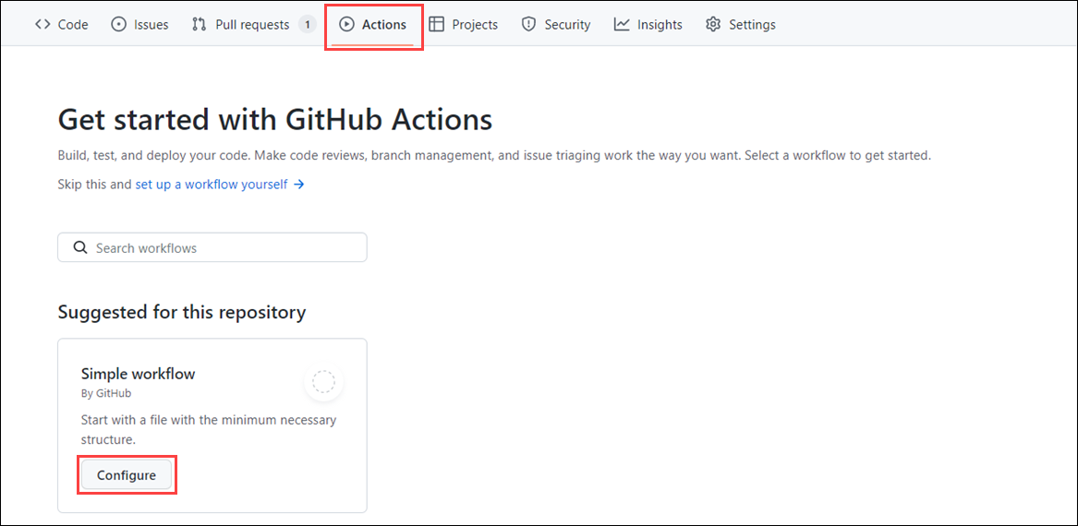
Using Open-Source Actions Safely
When using community actions, treat them like any open-source dependency:
- Review action.yml
Check inputs, outputs, and make sure the action does exactly what it claims.
- Check the GitHub Marketplace listing
Actions don’t have to be listed, but Marketplace entries often have clearer docs.
- Check if the action is “verified”
Verified ≠ guaranteed safe, but it means GitHub has reviewed the publisher.
- Pin the version
Always specify a Git ref / SHA / tag so the action doesn’t change unexpectedly.
Types of GitHub Actions
1. Container Actions
- Environment is packaged with the action (Docker-based).
- Run only on GitHub-hosted Linux runners.
- Work well for multi-language or complex dependency setups.
2. JavaScript Actions
- Environment is not included — runner provides it.
- Run on Linux, macOS, or Windows runners.
- Good for lightweight, fast actions.
3. Composite Actions
- Combine multiple workflow steps into a single action.
- Useful for bundling repeated commands or shared logic.
- Makes workflows cleaner and easier to maintain.
Anatomy of a GitHub Action
1. Actions Used Inside Workflows
Example workflow step:
steps:
- uses: actions/checkout@v1
- name: npm install and build webpack
run: |
npm install
npm run build
Key ideas:
- uses: → calls an existing action (example: checkout code).
- run: → executes shell commands on the runner.
2. Structure of a Container Action (Custom Action)
Example:
name: "Hello Actions"
description: "Greet someone"
author: "octocat@github.com"
inputs:
MY_NAME:
description: "Who to greet"
required: true
default: "World"
runs:
uses: "docker"
image: "Dockerfile"
branding:
icon: "mic"
color: "purple"
Key Parts Explained
A. Metadata (name, description, author)
- Describes what the action does.
- Shown in GitHub Marketplace if published.
B. Inputs
- Define variables the action expects (example: MY_NAME).
- Values are passed from the workflow that calls the action.
C. Runs Section
- Defines how the action executes.
- uses: docker → this is a container action.
- image: Dockerfile → GitHub builds and runs the container from this Dockerfile.
D. Branding
- Cosmetic details (icon & color) for Marketplace display.
What Is a GitHub Actions Workflow?
- A workflow is an automated process that runs tasks like build, test, package, release, deploy.
- Stored as a .yml file in:
- .github/workflows/
- A workflow contains:
  - events (what triggers it)
  - jobs (groups of tasks)
  - steps (individual actions or commands)
Triggering Workflows (the on: section)
Workflows run when certain events happen, e.g.:
Simple trigger
on: push
Multiple triggers
on: [push, pull_request]
Event configuration
Limit to branches, tags, schedules, etc.
on:
push:
branches: [main]
pull_request:
branches: [main]
page_build:
release:
types: [created]
Events trigger on all activity types unless types are specified.
Jobs
- Each workflow must have at least one job.
- A job runs on a runner (GitHub-hosted or self-hosted).
Example:
jobs:
build:
runs-on: ubuntu-latest
Steps
Steps are tasks inside a job.
Example:
steps:
- uses: actions/checkout@v1
- uses: ./action-a
with:
MY_NAME: "Mona"
- uses: = an action
- run: = shell commands
- Local actions can be referenced with paths like ./action-a.
Referencing Actions in Workflows
Workflows can use actions from four main sources:
A. Docker Hub images
uses: docker://image-name:tag
B. Public repositories (most common)
uses: actions/checkout@v3
🔒 Security tip: Prefer a full commit SHA to avoid unexpected changes.
C. Local repository actions
uses: ./path-to-action
D. Enterprise marketplace
uses: enterprise-org/action-name@v1
Important: Always pin versions (tag, ref, or SHA).
GitHub-Hosted vs Self-Hosted Runners
GitHub-Hosted Runners
- Fresh VM each job
- Simple, quick to use
- Limited customization
- Example:
- runs-on: ubuntu-latest
Self-Hosted Runners
- Fully customizable (hardware, OS, software)
- Can run on-prem or in the cloud
- Supports special workloads (large builds, specific OS)
- Example:
- runs-on: [self-hosted, linux, ARM32]
Larger GitHub-Hosted Runners
- Provide more CPU, RAM, disk for heavy workflows.
- Useful for:
  - large builds
  - big test suites
  - ML/data processing
  - video encoding
  - simulations
Example:
runs-on: ubuntu-latest-16core
- Same tools as standard runners, just more resources.
Managing Larger Runners
Monitor usage
- GitHub Actions usage page shows job count, runtime, and costs.
Control access
- Limit who can use larger runners.
Manage costs
- Use big runners only when needed.
- Optimize workflow runtime.
- Track billing regularly.
Scaling strategies
- Split large workflows into smaller jobs.
- Use self-hosted runners for predictable loads.
Workflow → Jobs → Steps → Actions
1. Workflows
- A workflow is the top-level automation process.
- Stored in .github/workflows/*.yml
- Triggered by events (push, pull_request, schedule, etc.).
- Must contain at least one job.
- Used for tasks like build, test, package, release, deploy.
2. Jobs
- A job is a group of steps executed on a runner.
- Runner can be:
  - GitHub-hosted (ubuntu-latest, windows-latest, etc.)
  - Self-hosted (your own machine)
- Defined using:
- runs-on: ubuntu-latest
- Jobs can run:
  - in parallel, or
  - depend on each other (via needs:)
3. Steps
- A step is an individual task inside a job.
- Steps can:
  - use actions
  - run shell commands
- Example:
- - uses: actions/checkout@v2
- - uses: ./action-a # local custom action
4. Actions
- Actions are reusable units of work—mini scripts or tools.
- A step can:
  - use an action
  - uses: actions/checkout@v2
  - or run a command
  - run: npm install
- Types of actions:
  - community actions
  - custom actions
  - local actions from the repo
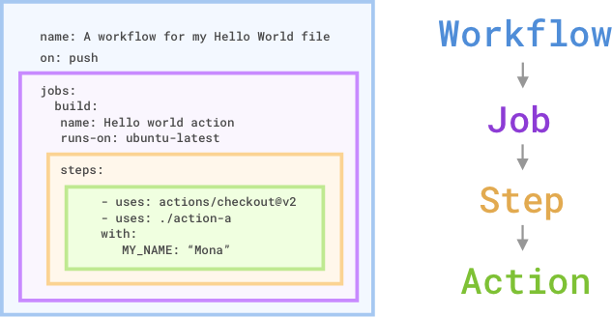
Configuring GitHub Actions Workflows
1. Workflow Triggers
Workflows run when triggered by events. Types of events:
- Scheduled (schedule)
  - Runs at specified times using cron syntax (UTC).
  - Example:
on:
schedule:
- cron: '*/15 * * * *' # every 15 minutes
on:
schedule:
- cron: '0 3 * * SUN' #every Sunday at 3:00am
  - Can specify days, times, or ranges. Minimum interval: 5 mins.
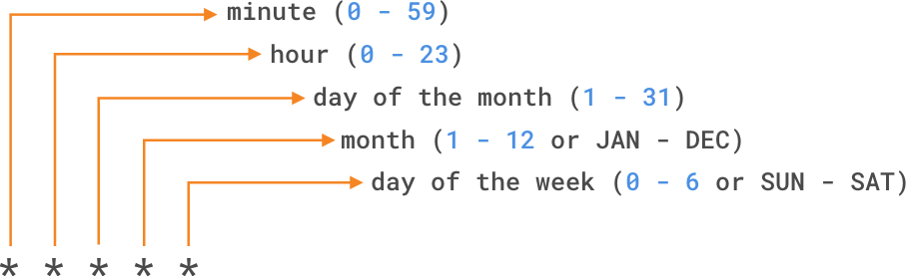
- Manual (workflow_dispatch)
  - Trigger via GitHub UI or REST API.
  - Can accept inputs like form fields:
on:
workflow_dispatch:
inputs:
logLevel:
description: 'Log level'
required: true
default: 'warning'
tags:
description: 'Test scenario tags'
- External (repository_dispatch)
  - Trigger workflows from outside GitHub (other CI/CD tools, repos, webhooks).
  - Send POST request with event_type and optional client_payload:
curl \
-X POST \
-H "Accept: application/vnd.github.v3+json" \
https://api.github.com/repos/octocat/hello-world/dispatches \
-d '{"event_type":"event_type"}'
on:
repository_dispatch:
types: [opened, deleted]
Use cases
- Trigger workflows from external CI/CD tools.
- Coordinate multi-repo deployments (for example, Repo A finishes build → triggers Repo B).
- Start automation based on external events (webhooks, monitoring alerts, CRON jobs outside GitHub).
- Chain workflow executions between repositories or within monorepos.
name: Custom Dispatch Listener
on:
repository_dispatch:
types: [run-tests, deploy-to-prod] # Optional filtering
jobs:
run:
runs-on: ubuntu-latest
steps:
- name: Echo the payload
run: |
echo "Event type: ${{ github.event.action }}"
echo "Payload value: ${{ github.event.client_payload.env }}"
Key elements:
- types: Optional. Defines custom event types like run-tests, deploy-to-prod, etc.
- github.event.client_payload: Access to any other custom data passed in the dispatch event.
- github.event.action: Name of the event_type sent.
Triggering the event via API
You must send a POST request to the GitHub REST API v3 endpoint:
POST https://api.github.com/repos/OWNER/REPO/dispatches
- Webhook events
  - Trigger on GitHub activities like check_run, issues, etc.
  - Can filter by activity type:
on:
check_run:
types: [rerequested, requested_action]

Endpoint and Authorization
- Endpoint:
- POST https://api.github.com/repos/OWNER/REPO/dispatches
- Authorization:
  - Requires a Personal Access Token (PAT) with repo scope.
  - For organizations, ensure your PAT has proper access.
Required Parameters
When sending the POST request, you include two main parameters in the JSON body:
Field | Type | Description | Required
event_type | string | A custom name for the event (maps to types in your workflow trigger) | Yes
client_payload | object | Arbitrary JSON to pass extra data to the workflow (github.event.client_payload) | No
How Parameters Work
event_type
- Identifies what triggered the workflow.
- Workflow uses it to filter which events to listen to.
- Example strings: "deploy", "run-tests", "sync-db"
- Inside workflow:
- - name: Print event type
- run: echo "Event type: ${{ github.event.action }}"
client_payload
- Pass custom data like environment, version, build ID, etc.
- Workflow can access these values using github.event.client_payload.
- Example inside workflow:
- - name: Show payload values
- run: |
- echo "Environment: ${{ github.event.client_payload.env }}"
- echo "Version: ${{ github.event.client_payload.version }}"
Sample Payload
{
"event_type": "deploy-to-prod",
"client_payload": {
"env": "production",
"build_id": "build-456",
"initiator": "admin_user",
"services": ["web", "api", "worker"] }}
- event_type: "deploy-to-prod" → triggers workflows listening for this type.
- client_payload: contains all additional context needed by the workflow.
Sample cURL Command
curl -X POST \
-H "Accept: application/vnd.github+json" \
-H "Authorization: token YOUR_GITHUB_TOKEN" \
https://api.github.com/repos/OWNER/REPO/dispatches \
-d '{"event_type":"run-tests","client_payload":{"env":"staging"}}'
- Sends a repository_dispatch event to your repo.
- Workflow that listens for "run-tests" will start and receive the payload.
Conditional Keywords (if)
- Purpose: Control whether a job or step runs based on certain conditions.
- Syntax:
if: <expression>
or
if: ${{ <expression> }}
  - ${{ }} tells GitHub to evaluate the expression instead of treating it as a string.
  - For some common expressions, GitHub automatically evaluates them, so you can omit ${{ }}.
- Example: Run a job only on the main branch:
jobs:
prod-check:
if: github.ref == 'refs/heads/main'
runs-on: ubuntu-latest
steps:
- name: Build project
run: echo "This runs only on main branch"
- Contexts you can use in expressions:
  - github (e.g., branch, event type)
  - env (environment variables)
  - job (job outputs, status)
  - steps (step outputs)
  - matrix (from matrix builds)
- Example with a step conditional:
steps:
- name: Run tests only if in staging
if: ${{ github.event.client_payload.env == 'staging' }}
run: echo "Running staging tests"
Disabling and Deleting Workflows
- Disable: Stop a workflow from being triggered without deleting it. Useful if:
  - Workflow is causing errors or too many requests.
  - You need to pause scheduled workflows.
  - External services are down.
- How to disable:
  - GitHub UI: Actions tab → select workflow → Disable workflow.
  - API: Use GitHub REST API to disable or enable workflows.
- Delete: Permanently remove a workflow file or cancel a running workflow:
  - Cancel workflow run: Stops all jobs/steps in progress.
  - Delete file: Removes workflow completely from repository.
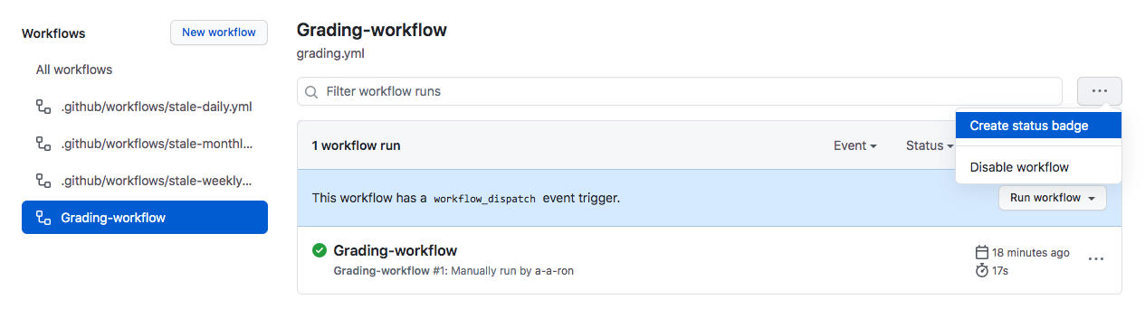
When to Disable or Cancel Workflows
Disabling a workflow temporarily can help prevent problems without deleting it. Some common scenarios:
- Errors causing too many/wrong requests → Could negatively affect external services.
- Non-critical workflows consuming too many minutes → Save resources on your account.
- External service is down → Avoid failed requests or errors.
- Forked repositories → Some workflows (like scheduled workflows) may not be needed.
Using Organization Workflow Templates
- Purpose: Promote consistency and avoid duplicating workflows across multiple repositories.
- Where it lives: .github repository in the organization.
- How to use:
  - Navigate to the Actions tab in a repo.
  - Select New workflow.
  - Choose from the section “Workflows created by organization name.”
- Benefit: Teams across the organization can use standardized workflows without recreating them.
Referencing Specific Versions of Actions
Referencing a specific version of an action ensures your workflow is stable and not broken by updates to that action. There are several ways to reference:
steps:
# Specific commit SHA (most secure)
- uses: actions/setup-node@c46424eee26de4078d34105d3de3cc4992202b1e
# Major version
- uses: actions/setup-node@v1
# Minor version
- uses: actions/setup-node@v1.2
# Branch (less secure, latest branch changes)
- uses: actions/setup-node@main
Recommendation:
- For stability and security, prefer a commit SHA of a released action.
- Using a branch reference can be risky because it may include unexpected changes.

GitHub Copilot - AI for Coding & Development

GitHub Copilot is an AI pair-programming assistant that helps you write code, create files, refactor projects, generate documentation, and troubleshoot issues—all directly from your coding environment.

With Copilot Chat in Visual Studio Code, you can set up an entire project from scratch using natural-language instructions.

Below is a full walkthrough of:
- Setting up your local environment
- Installing and enabling GitHub Copilot
- Creating a new project using Copilot Chat

🧰 1. Set Up Your Local Environment

Before using GitHub Copilot to create projects, ensure your environment is ready.

✅ Step 1: Install Visual Studio Code

Download VS Code (if you don't already have it).

VS Code → Install → Launch

✅ Step 2: Install Required Runtimes (depending on your project type)

Here are common options:

For JavaScript / TypeScript projects
- Install Node.js (LTS recommended)

For Python projects
- Install Python 3.x

For C# / .NET projects
- Install .NET SDK

For Java projects
- Install JDK (17 or above)

For Web Development
- No extra tools required, but Node.js is recommended.

✅ Step 3: Sign into GitHub in VS Code
- Open VS Code
- Select Account → Sign in with GitHub
- Authorize VS Code

✅ Step 4: Set up GitHub Copilot Extensions

VS Code automatically installs both extensions when you set up Copilot:
- GitHub Copilot (code completions)
- GitHub Copilot Chat (AI assistant)

If not installed:
- Open Extensions (Ctrl+Shift+X)
- Search for:
  - GitHub Copilot
  - GitHub Copilot Chat
- Install both

You should now see the Copilot icon in the side panel.

💬 2. Create a New Project Using GitHub Copilot Chat

Now that your environment is ready, you can use Copilot Chat to create a project from scratch, using natural-language commands.

🚀 Step 1: Open Copilot Chat

Use any of these methods:
- Click the Copilot Chat icon
- Use shortcut Ctrl + Alt + I
- Use the command palette → "Copilot Chat: Open"

🚀 Step 2: Create Your Project Using AI

You can now ask Copilot Chat:

Example project creation prompts

🟦 Create a Web App (HTML/CSS/JS)

Create a new folder for a simple web application.

Add an index.html file with a basic layout, a styles.css file, and a script.js file.

Make the page display “Hello from GitHub Copilot!” and style it nicely.

🟧 Create a Node.js project

Create a new Node.js project in the current workspace.

Initialize package.json, create an app.js file, and add Express with a “Hello World” route.

🟪 Create a Python project

Create a new Python project with a main.py file.

Add a virtual environment, and write a basic CLI calculator in main.py.

🟥 Create a .NET console app

Create a new .NET 8 console application in this workspace.

Add a Program.cs that prints a random motivational quote.

Copilot will:

✔ create folders
✔ generate files
✔ write code
✔ explain what it did
✔ open edited files in the editor

🚀 Step 3: Modify the Project Using Inline Chat or Edit Mode

If you want to update part of your project, use:

Inline Chat (Ctrl + I):
- Highlight code
- Ask: “Rewrite this to use async/await.”
- Accept or refine changes

Edit Mode in Chat View

Example prompt:

Refactor the entire project to use environment variables for configuration.

Copilot will update multiple files at once.

🚀 Step 4: Run the Project

After Copilot generates the project:

For Node.js

npm install

node app.js

For Python

python main.py

For .NET

dotnet run

🌐 GitHub Copilot for HTML & JavaScript

GitHub Copilot is extremely effective for front-end development. It can:

✔ Generate boilerplate HTML
✔ Create JavaScript functions
✔ Build UI components
✔ Suggest DOM operations
✔ Create CSS styles
✔ Debug JavaScript errors
✔ Explain code
✔ Generate full apps (JS, HTML, CSS, API calls, etc.)

Below is everything you need to get started.

🧰 1. Setup for HTML/JavaScript Development

Requirements
- Visual Studio Code
- GitHub account
- GitHub Copilot + Copilot Chat extensions installed
- Optional but recommended:
  - Live Server extension (for previewing HTML)
  - Node.js (if working on backend JS or tools like Vite)

🏁 2. Create a New HTML/JavaScript Project Using Copilot

Open Copilot Chat (Ctrl+Alt+I) and ask:

Prompt

Create a simple HTML and JavaScript project in this workspace.

Include index.html, styles.css, and script.js.

Make a basic webpage with a button that displays an alert when clicked.

Copilot will:

✔ Create the files
✔ Generate HTML structure
✔ Add JavaScript logic
✔ Link script.js and styles.css

Expected output:

index.html

<!DOCTYPE html>

<html lang="en">

<head>

<meta charset="UTF-8" />

<meta name="viewport" content="width=device-width, initial-scale=1.0" />

<title>Copilot Demo</title>

<link rel="stylesheet" href="styles.css" />

</head>

<body>

<h1>Hello from GitHub Copilot!</h1>

<button id="alertBtn">Click me</button>

<script src="script.js"></script>

</body>

</html>

script.js

document.getElementById("alertBtn").addEventListener("click", () => {

alert("Button clicked!");

});

styles.css

body {

font-family: Arial, sans-serif;

padding: 20px;}

button {

padding: 10px 20px;

cursor: pointer;}

💬 3. Using Inline Chat to Modify HTML & JavaScript (Ctrl+I)

Inline chat is perfect when updating a specific part of your UI or logic.

Example: Add a list of items dynamically
- Highlight this part of script.js
- Press Ctrl+I
- Ask Copilot:

Add code that generates a list of 5 random numbers and appends them to the page.

Copilot will generate something like:

const list = document.createElement("ul");

for (let i = 0; i < 5; i++) {

const li = document.createElement("li");

li.textContent = Math.floor(Math.random() * 100);

list.appendChild(li);

}

document.body.appendChild(list);

Press Accept to apply.

⚡ 4. Autocomplete Productivity Tips for HTML & JS

✨ HTML Autocomplete Examples

Type:

nav

Copilot may generate a complete nav bar.

Type:

<!-- create a login form -->

Copilot often creates:

✔ Input fields
✔ Labels
✔ Submit button

✨ JavaScript Autocomplete Examples

Start typing:

function fetchData() {

Copilot might auto-complete:

fetch("https://api.example.com/data")

.then(res => res.json())

.then(data => console.log(data))

.catch(err => console.error(err));

Or, type:

const numbers =

Copilot may generate an array or logic based on context.

🧠 5. Using Smart Actions for HTML/JavaScript

Right-click → Copilot → Smart Actions

⭐ Explain Code

Great when inheriting a legacy JS file.

⭐ Fix Code

If a <script> gives an error, Copilot suggests fixes.

⭐ Generate Docs

Useful for documenting JS functions.

⭐ Generate Tests

Creates Jest or Mocha tests if detected in project.

🔥 6. Real-World Workflows with GitHub Copilot (Examples)

▶ Build interactive components

Prompt:

Add a JavaScript modal popup to the page with open and close buttons.

Copilot generates:
- Modal HTML
- CSS
- JS logic

▶ Create animations

Prompt:

Create a CSS animation that fades in the H1 title.

Copilot suggests keyframe animations.

▶ Fetch API data

Prompt:

Write JavaScript that fetches data from the Pokémon API and displays the names in a list.

Generates asynchronous fetch logic with DOM updates.

▶ Convert vanilla JS → modern ES6

Inline Chat:

Refactor this code to use ES6 features like arrow functions and const/let.

Copilot rewrites the file.

▶ Fix runtime errors

Smart Action → Fix:
- Undefined variables
- Incorrect DOM selectors
- Mis-typed method names

🔧 7. Example: Build a Full Mini-App Using One Chat Prompt

You can create a full HTML/JavaScript application in one prompt:

Create a small HTML/JavaScript to-do list application.

It should allow adding tasks, removing tasks, and marking tasks as completed.

Style it in styles.css with a clean, modern UI.

Copilot typically generates:
- index.html with input + buttons
- script.js with task logic
- styles.css with UI styling

The whole app is functional immediately.

GitHub Copilot – Features, Tips & Tricks (Short Notes)

1. Inline Comments (Inline Chat)
- You can write inline comments to generate HTML or JS code automatically.
- Example comment: <!-- create username input and validate with regex -->

Copilot generates:
  - <input> tag for username
  - JavaScript validation using your custom regex
- You can define your own rules inside comments, and Copilot writes the code.

2. Providing Context (Very Important for Good Suggestions)

Copilot gives accurate suggestions only when the right context is included.

Ways to provide context:
- Open the file and ask a question — Copilot reads the file automatically.
- Add the entire workspace using @workspace.
- Add specific files using @file:<filename>.

If you ask without context → Copilot may not understand the code.

3. Prompting Techniques
- You can write examples in the prompt → Copilot suggests better solutions.
- You can ask for:
  - Built-in JS functions
  - Third-party libraries
- Copilot suggests automatically even if you don’t provide examples.

4. Unit Test Case Generation
- Select code → add file as context → ask “generate unit tests”.
- Copilot:
  - Creates a test plan
  - Lists all scenarios
  - Generates actual test code
(e.g., Jest, Mocha, JUnit depending on language)

5. Explain Code
- Use:
- @workspace/explain
- Select the code → Copilot explains:
  - What each line does
  - Examples
  - Edge cases

Great for learning or reviewing unfamiliar code.

6. Assist With Terminal Errors
- You can use:
- @terminal
- Copilot explains errors thrown in VS Code terminal.
- Also suggests commands.
- You can run commands directly using the magic icon next to the suggestions.

7. Commit Message Generation
- When committing code, select the magic Copilot icon.
- Copilot generates a clean, meaningful commit message.

8. Copilot Chat in Mobile App
- GitHub Copilot app works like ChatGPT.
- Features:
  - Chat about code
  - View repos
  - Make code changes
  - Commit directly from mobile

9. Public Repository Suggestions
- Copilot uses public GitHub repos for reference.
- Can disable under:
Settings → Copilot → “Suggestions matching public code”
- Developers can be allowed/blocked at enterprise level.
- You can check matches in:
View → Output → GitHub Copilot Log

10. Refactor Code
- Select code → ask Copilot to refactor with:
  - Modern JavaScript / Java / Python / etc.
  - Remove redundancies
  - Improve readability
  - Reduce lines
- Copilot provides:
  - A refactor plan
  - Updated code

11. Generate Backend Code

Prompt example:

Create a backend API with minimal external libraries.

Highlight vulnerabilities and fixes.

Provide instructions to run server.

Copilot:
- Generates backend code (Node, Java, C#, etc.)
- Minimizes third-party dependencies
- Highlights vulnerabilities
- Suggests secure alternatives

12. Detect Vulnerabilities

Use prompt:

Check this code for vulnerabilities and provide fixes.

Copilot scans:
- SQL injection
- XSS
- Hard-coded secrets
- Weak auth
- Insecure APIs
and provides fixes.

13. Learning Tool – Auto-Generate Quizzes
- Select files → ask:
- Create a quiz to help me learn this codebase.
- Copilot generates:
  - MCQs
  - Short-answer questions
  - Code understanding exercises

14. Generate Dummy Data

Prompt example:

Generate JSON dummy data with random IDs, dates, names.

Copilot creates realistic mock data.

15. VS Code Customization via Copilot

Use:

@vscode

Ask things like:
- Change theme
- Enable auto-save
- Modify font size
- Extension recommendations

16. GitHub Copilot CLI

Steps:
- Install GitHub CLI (gh)
- Login
- Install Copilot CLI extension

Features:
- explain → explains any command
- suggest → generates shell commands based on natural language

17. VS Code Snippets (Manual + Copilot Assisted)
- Go to:
Settings → Configure Snippets → JavaScript
- Create custom snippet
- Assign unique prefix
- When typing prefix, snippet appears
- Copilot expands and enhances snippet automatically.

Example use:
- Auto-generate dummy data
- Custom loops
- Standard function templates

18. Prompt Shortcuts / Magic Commands

Context Variables
Shortcut | Meaning
#selection | Use selected code
#editor | Use visible editor code
#file:<name> | Add specific file as context
#terminalLastCommand | Analyze last terminal command
#terminalSelection | Use selected terminal output
#vscodeApi | Info about VS Code API

19. Quick Access Options in Right-Click Menu
- Add file / Add selection → adds context
- Start in editor → inline chat
- Fix → resolves errors
- Explain This → explains code
- Generate Tests → creates unit tests
- Generate Docs → generates documentation above functions

20. Convert JavaScript to Python

Steps:
- Install Python extension
- Select JS code
- Use prompt:
- Convert #selection to Python.

Copilot generates equivalent Python code.

21. Copilot in Other IDEs
- GitHub Copilot works in:
  - VS Code
  - Visual Studio
  - JetBrains (PyCharm, IntelliJ, WebStorm)
  - Neovim/VIM
  - Eclipse

22. Change AI Models

You can switch between:
- GPT-4
- GPT-5
- GPT-4o
- Smaller models

For performance or accuracy differences.

23. Copilot Edits
- Add one or multiple files as context
- Provide prompt:
- Update these files to implement <new requirement>.
- Copilot provides:
  - Descriptions of changes
  - Multi-file edits
  - You can keep or undo changes

GitHub Copilot for React Developers

✅ 1. Setup GitHub Copilot for React Development

Step 1 — Install VS Code

Download and install latest Visual Studio Code.

Step 2 — Sign in & Install Copilot

VS Code → Status Bar → Copilot Icon → Set up Copilot

Copilot automatically installs:
- GitHub Copilot (code completions)
- GitHub Copilot Chat (chat-based coding help)

Step 3 — Configure Copilot for React

Go to: Settings → Extensions → GitHub Copilot

Enable:
- ✔ React / JavaScript / TypeScript completions
- ✔ Suggestions inline
- ✔ Chat access

Optional:
- Enable "Suggestions matching public code" for more examples
- Add your React app folder as workspace

Step 4 — Start a React Project (Copilot-assisted)

Inline prompt example:

// create a new react project with vite and typescript

Copilot will suggest:

npm create vite@latest my-app -- --template react-ts

cd my-app

npm install

npm run dev

💡 2. Using Copilot for React Development

Copilot provides:
- Component generation
- Hooks
- Form validation
- API calls
- State management
- React Router setup
- Redux / Zustand boilerplate

🎯 3. React Form Validation with Copilot

Copilot can generate validation logic with custom rules using inline comments.

Example 1: Create Input With Custom Validation

Write an inline comment:

{/* create a username input and validate using regex: only letters, min 4 chars */}

Copilot generates (example):

const [username, setUsername] = useState("");

const [error, setError] = useState("");

const usernameRegex = /^[A-Za-z]{4,}$/;

const handleBlur = () => {

if (!usernameRegex.test(username)) {

setError("Username must be at least 4 letters and contain only alphabets.");

} else {

setError("");

}

};

return (

<div>

<input

type="text"

value={username}

onChange={(e) => setUsername(e.target.value)}

onBlur={handleBlur}

placeholder="Enter username"

/>

{error && <p className="error">{error}</p>}

</div>);

Example 2 — Entire Form Validation

Comment:

// create a login form with email, password validations and disable button until valid

Copilot generates:
- React controlled inputs
- Email regex
- Password strength validation
- Real-time error messages
- Button disabled until form valid

💡 Tips for Better Validation Prompts

Example prompts:
- Add custom rule
- enforce no whitespace and no special characters in username
- Ask Copilot to optimize validation
- refactor this validation using react-hook-form
- Add context
- @file:Login.tsx
- update validation to include strong password checker

🧪 4. Generate React Unit Test Cases

Copilot can generate tests for:
- Components
- Hooks
- API calls
- Context providers
- Redux slices

Compatible with:
- Jest
- React Testing Library
- Vitest

How to Generate Tests
- Select the component code
- Right-click → Copilot → Generate Tests
- Add file context:
- @file:MyComponent.jsx
- Copilot first creates a test plan
- Copilot then generates test code

Example: React Component

Component:

function Greeting({ name }) {

return <h1>Hello {name}</h1>;}

Prompt:

Generate unit test cases using React Testing Library for #selection

Copilot Output:

import { render, screen } from "@testing-library/react";

import Greeting from "./Greeting";

test("renders greeting message", () => {

render(<Greeting name="John" />);

expect(screen.getByText("Hello John")).toBeInTheDocument();

});

Example: Tests for Validation Component

Prompt:

@file:LoginForm.jsx

Generate comprehensive unit tests to verify validation rules and disabled button state.

Copilot covers:
- Empty inputs
- Invalid email format
- Weak password
- Button disabled
- Successful submission

⚙️ 5. Copilot Smart Actions for React Projects

Right-click inside component → Copilot menu:

✔ Fix errors
✔ Explain code
✔ Review & comment
✔ Refactor with modern React
✔ Generate docs (/** */)
✔ Generate tests

⚡ 6. React Debugging With Copilot

Use commands:
- @terminal
- @workspace/explain

Examples:
- Explain React error:
- @terminal explain this error: Cannot read properties of undefined (reading 'map')
- Fix component:
- fix this component, it throws error when props are null

🛠 7. Refactoring React Code With Copilot

Prompt examples:

Refactor this component to use hooks instead of class components.

Optimize useEffect to avoid infinite loops.

Convert to TypeScript with proper types.

Copilot provides:
- A refactor plan
- Updated code

🚧 8. Generate Backend Code for React App

Examples:

create an express backend with jwt auth for this react app

create API mock server for testing using json-server

🛡 9. Detect Security Issues in React

Prompt:

scan this component for vulnerabilities and suggest fixes

Copilot identifies:
- XSS
- Unsafe HTML injection
- Weak API calls
- Token exposure
- Missing error handling

🎓 10. Learning React Codebase with Copilot

Prompt:

create a quiz for selected React files to help me understand the project

Great for onboarding new developers.

Other AI Tools for Web Developers

Cursor
- Cursor is essentially a code editor (a fork of VS Code) built around AI-assisted coding: autocomplete, natural-language prompts, smart rewrites, multi-file editing, and codebase-wide chat. Wikipedia
- Pros: lets you treat English instructions as “code commands.” You can ask it to generate features, refactor code, even rewrite whole modules. Good for rapid iteration and AI-driven workflows. Wikipedia+1
- Use cases: prototyping, quick scaffold generation, refactoring, “vibe coding” style fast experimentation.

Vercel v0 (or just “v0” by Vercel)
- v0 is described as a tool built for rapid UI prototyping. It helps generate UI components, front-end layouts, and makes building UI with frameworks (like React) faster. Medium+1
- Pros: very helpful when you want to quickly mock up or prototype UIs — get basic layouts or components up in minimal time, then refine. Especially useful for front-end / web projects. Medium
- Limitation: often focused on UI/layout. Business logic or complex backend tasks may still need manual coding or a more robust tool. apidog+1

Claude AI / Claude Code (from Anthropic)
- Claude is a general-purpose LLM / AI assistant. Many developers report it handles UI design prompts and UI logic — in some cases they find it “better for UI than other LLMs.” (As you noted.)
- When combined with tools like v0 or Cursor, Claude (or Claude Code) can serve as the “brain” for generating or reasoning about code — while those tools handle structure, editing, and scaffolding.

⚙️ Typical Workflow — Mixing These Tools + Your Stack

You can combine tools for different parts of development. For example:
- Use v0 to generate a quick UI prototype (React component, layout, styling).
- Import that output into Cursor to refine, add business logic, integrate APIs, or restructure code.
- Use Claude / Claude Code for reasoning — e.g. ask “is this UI accessible?”, “add validation logic”, or “refactor for performance/security.”
- Use your own tooling (linters, build tools, tests) to finalize, review, and deploy.

This hybrid approach mixes speed of prototyping with flexibility + control for production-quality code.

✅ When to Use Which Tool — Quick Guide
Need / Situation | Recommended Tool(s)
Rapid UI mockup or front-end prototype | Vercel v0, Claude (for prompts)
AI-assisted writing, refactoring, scaffolding, or multi-file edits | Cursor, Claude Code
Reasoning about logic, validation, architecture, code review | Claude / Claude Code, possibly Copilot or Cursor
Full project scaffold: UI + basic logic + boilerplate | v0 (UI) + Cursor (logic) + manual polishing
Quick experiments, “vibe coding,” learning patterns | Cursor or Claude-driven workflows

⚠️ Things to Keep in Mind & Best Practices
- AI isn’t perfect: Generated code still needs review, testing, and sometimes manual fixes. Don’t treat AI output as final production code.
- Use AI + human judgment together: Leverage AI for boilerplate, repetitive tasks, or ideas; but make sure to audit logic, security, and performance manually.
- Combine strengths: Use UI-focused tools (v0) for layout; AI-coding editors (Cursor) for logic and refactors; LLMs (Claude) for reasoning, docs, or conceptual tasks.
- Avoid over-reliance: Over-automating everything may lead to messy code or technical debt. Use AI as an assistant — not a replacement.

GitHub Copilot — Agent Mode Explained

Agent Mode is the most powerful mode in GitHub Copilot Chat.
Instead of just answering questions or suggesting edits, Copilot becomes an autonomous coding agent that can:

✔️ Plan a multi-step solution
✔️ Edit multiple files
✔️ Run tools
✔️ Execute commands in your terminal (with permission)
✔️ Iterate until the task is complete

Think of Agent Mode as:
👉 “AI that writes, tests, and modifies code, using tools, without needing step-by-step prompts.”

🧠 How Agent Mode Works

When you enter a task in Agent Mode, Copilot will:

1. Understand your high-level prompt

Example:“Add form validation for the username field across the React codebase, and update unit tests.”

2. Generate a plan

Copilot outlines steps like:
- Locate relevant files
- Update component logic
- Add validation logic
- Update tests
- Run tests
- Apply fixes based on test output

3. Invoke tools automatically

Agent Mode uses supported tools such as:
- File editor → to modify or create files
- Terminal runner → to run build or test commands
- Search tools → to find symbols or file content

4. Ask for confirmation when needed

Especially when:
- Running terminal commands
- Using tools that modify files
You’ll see a Continue button with choices:
- Continue once
- Always allow for this workspace
- Always allow

5. Apply updates directly in your editor

Changes appear as diff/edit views with Accept / Undo controls.

📌 How to Enable/Use Agent Mode

Step 1 — Open the Chat View
- Click the Copilot icon
- Or press Ctrl+Alt+I

Step 2 — Switch to Agent Mode

Bottom-left of the chat → Set mode → Agent

Step 3 — Give a high-level task

Example prompts:
- “Optimize the React app for performance, identify bottlenecks, and apply needed fixes.”
- “Create an Express.js server with JWT authentication and write tests. Keep dependencies minimal.”
- “Refactor the project to TypeScript and fix all type errors.”

Step 4 — Approve tool/terminal actions

Copilot will ask before running commands like:
- npm test
- npm install
- git diff
- eslint --fix

Step 5 — Review the edits

You will see diffs and status updates in the chat.
You can:
- Keep
- Undo
- Keep some files only

🛠️ What You Can Do in Agent Mode

✔️ 1. Multi-file refactoring

Example:

“Convert all JavaScript files to TypeScript and fix typing errors.”

✔️ 2. Build features end-to-end

Frontend + backend + tests

“Add user registration with email and password. Validate input, handle errors, write tests.”

✔️ 3. Fix breaking builds

“The build is failing. Diagnose and fix all errors.”

✔️ 4. Run scripts automatically

(Copilot will ask first)

“Run the project and fix all runtime errors.”

✔️ 5. Auto-debugging

“Tests are failing. Run the tests and fix failures.”

✔️ 6. Codebase onboarding

“Explain architecture, find unused components, and list tech stack.”

✔️ 7. Cleanup & modernization

“Refactor React code to modern standards: hooks, functional components, no deprecated APIs.”

💡 Tips for Best Use

Tip 1 — Give high-level goals, not line-by-line instructions

✔️ Good:

“Add password validation across app and update any related UI errors.”

✘ Bad:

“Edit login.js; add regex here.”

Tip 2 — Use context buttons

Add context via:
- Files
- Search results
- Problems tab
- Recent files
- Terminal output

More context → much better results.

Tip 3 — Watch for “premium request” usage

Agent Mode often uses several premium requests per task because it:
- Runs multiple steps
- Writes multi-file updates
- Invokes tools

Tip 4 — Review edits like a code review

Never blindly accept.
AI can:
- Break logic
- Miss edge cases
- Introduce security issues

Tip 5 — Combine with other modes

Use:
- Ask Mode for questions
- Edit Mode for single-file updates
- Agent Mode for large tasks

🧪 Example: Agent Mode for React Developer

Prompt

“Add username validation in the signup form using a regex rule:
- Min 4 chars
- No special characters
- No spaces
Update UI error messages and write Jest unit tests.”

What Agent Mode will do
- Search for signup form files
- Add validation logic
- Update state & error UI
- Create validateUsername.js helper
- Write unit tests
- Run Jest
- Fix failing tests and re-run
- Apply final edits

All autonomously.

Introduction to GitHub Copilot

GitHub Copilot is an AI-powered coding assistant designed to help developers write code faster and more efficiently. It integrates directly into popular IDEs (like Visual Studio Code) and offers contextual suggestions that match your coding style.

Benefits:
- Increases productivity.
- Improves code quality.
- Supports developer preferences.
- Fits into the Software Development Lifecycle (SDLC).
- Enhances team efficiency and developer satisfaction.

Learning Objectives

By the end of this module, you should be able to:
- Integration: Identify how Copilot integrates into workflows and supports coding styles.
- SDLC Impact: Explore Copilot’s potential effects on different SDLC stages (e.g., coding, testing, maintenance).
- Limitations & Efficiency: Recognize AI-assisted coding limitations and evaluate its effect on developer productivity.

Prerequisites

To get the most out of this module, you need:
- Basic software development knowledge.
- Familiarity with at least one programming language.
- A GitHub account and knowledge of GitHub basics.
- Access to GitHub Copilot (Free tier or higher).

Tip:
- Free tier: 2,000 code autocompletes + 50 chat messages/month.
- Sign in via Visual Studio Code → GitHub Copilot icon → Sign in to Use GitHub Copilot for Free.
- Students, educators, and open-source maintainers may be eligible for Copilot Pro for free. Learn more: Copilot for Students.

Module Focus
- How Copilot helps developers code faster and more confidently.
- How it allows developers to stay focused and tackle complex challenges.
- How it fits into the modern development workflow.

Boost Developer Productivity with GitHub Copilot

GitHub Copilot streamlines development workflows, enabling developers to focus on solving complex problems instead of repetitive coding tasks.

Unit Learning Objectives:
- Understand how AI tools like Copilot reduce repetitive coding efforts.
- Identify workflow areas where Copilot has the biggest impact.

Key Productivity Use Cases
- Accelerate Learning New Languages and Frameworks
  - Provides context-aware code suggestions to demonstrate usage of unfamiliar functions and libraries.
  - Supports a wide range of languages, easing transitions.
  - Integrates with documentation by showing API usage inline.
  - Example: Learning Golang and using Copilot’s “Explain this” feature.
- Minimize Context Switching
  - Offers in-editor assistance to reduce searches for solutions online.
  - Suggests correct method calls and parameters without leaving the IDE.
  - Autocompletes repetitive code to maintain focus.
- Enhanced Documentation Writing
  - Generates inline comments and function descriptions.
  - Helps create consistent README files.
  - Maintains documentation style and clarity across the project.
- Automate Routine Tasks
  - Generates boilerplate code, sample data, and unit tests.
  - Assists in code translation and refactoring.
  - Handles repetitive development tasks, saving time for creative work.
- Advanced Automation Scenarios
  - Builds database schemas, ORMs, API endpoints, and config files.
  - Sets up test infrastructure for complex projects.
  - Example: Creating a microservice with Docker, CI/CD, and monitoring from simple comments.
- Story-driven Development Automation
  - Converts user stories into production-ready implementations.
  - Implements business logic, integration patterns, and end-to-end features automatically.
  - Includes error handling, input validation, and logging in generated code.
- Accelerate Pull Request Workflows
  - Generates PR-ready code with proper documentation and tests.
  - Assists in review preparation, drafting comments, and resolving conflicts.
  - Ensures consistent patterns and faster iterations.
- Collaborative Development Workflows
  - Maintains coding standards across teams.
  - Facilitates knowledge sharing and context preservation.
  - Resolves merge conflicts with AI-assisted insights.
- Orchestrated AI Workflows
  - Multi-agent patterns: Draft → Review → Documentation → Test agents.
  - Ensures thorough, production-ready code with specialized focus for each task.
- Advanced Reasoning Capabilities
  - Analyzes complex codebases and relationships between components.
  - Suggests architectural improvements and coordinated multi-file changes.
  - Handles complex refactoring while preserving functionality.
- Automated Story Completion Workflows
  - Transforms user stories into complete features.
  - Includes integration, error handling, logging, and monitoring.
  - Reduces time from idea to working software.
- Personalized Code Completion
  - Adapts to individual coding style and project context.
  - Learns from developer patterns to provide more relevant suggestions over time.

Takeaway

By leveraging GitHub Copilot:
- Developers spend less time on routine tasks.
- Learning new technologies becomes faster and smoother.
- Focus is maintained on complex, strategic problems.
- Team collaboration and code quality improve.

Aligning GitHub Copilot with Developer Preferences

GitHub Copilot is designed to integrate seamlessly into developer workflows, adapting to coding styles, project contexts, and personal preferences.

1. Code Generation and Completion
- Multiple suggestions: Offers alternative solutions in ambiguous scenarios for developer choice.
- Language-specific idioms: Suggests idiomatic and best-practice patterns in the relevant programming language.

2. Writing Unit Tests and Documentation
- Test case generation: Suggests test cases, including edge cases developers might miss.
- Documentation stubs: Creates initial comments for functions, classes, and modules.
- Comment expansion: Expands brief comments into detailed explanations.

3. Code Refactoring
- Pattern recognition: Identifies common patterns and proposes cleaner, more efficient alternatives.
- Modern syntax suggestions: Offers updates using newer language features.
- Consistency maintenance: Helps align refactoring with the project’s coding style.

4. Debugging Assistance
- Error explanations: Provides plain-language interpretations of error messages.
- Log statement generation: Suggests logs to help trace complex issues.
- Test case suggestions: Proposes additional tests for tricky bugs.

5. Data Science Support
- Statistical functions: Helps implement statistical methods for datasets.
- Data visualization: Suggests plotting and charting using libraries like Matplotlib, Seaborn, Plotly.
- Data preprocessing: Offers code for handling missing data, encoding, scaling, etc.
- Model evaluation: Assists in creating evaluation metrics and performance visualizations.

6. Streamlined, Developer-Friendly Workflows
- Integrated development experience: Works inside IDEs, aware of project context, minimal configuration required.
- Autonomous task completion: Generates end-to-end features including tests and documentation.
- Smart defaults and progressive enhancement: Produces sensible defaults, letting developers refine code iteratively.
- Quality-first automation: Ensures security, error handling, and adherence to coding standards automatically.

Takeaway

GitHub Copilot adapts to developer preferences by:
- Reducing repetitive work.
- Supporting high-quality, idiomatic code.
- Enhancing productivity without compromising flexibility or code quality.

It becomes more than a code completion tool—a personalized coding assistant that aligns with individual and team workflows.

GitHub Copilot in the SDLC

GitHub Copilot isn’t just a coding assistant—it can enhance nearly every stage of the SDLC, from requirements to maintenance.

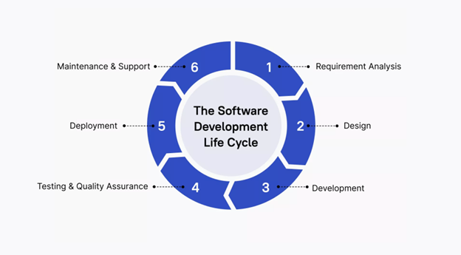

1. Requirement Analysis
- Rapid prototyping: Generate code snippets from high-level descriptions.
- User story implementation: Transform stories into initial functions/classes.
- API design: Suggest API structures based on described functionality.

2. Design & Development
- Boilerplate code generation: Automates repetitive structures.
- Design pattern implementation: Recommends suitable patterns for context.
- Code optimization: Suggests more efficient or idiomatic code.
- Cross-language translation: Helps move concepts/code between languages.

3. Testing & Quality Assurance
- Unit test creation: Generate tests from function signatures and behavior.
- Test data generation: Produce realistic datasets automatically.
- Edge case identification: Suggests tests to cover unusual scenarios.
- Assertion suggestions: Recommends appropriate assertions.

Automated Testing Workflows
- Test suite architecture: Build unit, integration, and end-to-end test frameworks.
- Test automation pipelines: Integrate with CI/CD for automatic test runs.
- Quality gates: Ensure code meets standards before promotion.
- Performance testing: Generate benchmarks and load testing scripts.

4. Deployment
- Configuration files: Assist in generating environment-specific configs.
- Deployment scripts: Suggest commands for common deployment tasks.
- Documentation updates: Keep deployment guides in sync with changes.

5. Maintenance & Support
- Bug fix suggestions: Propose fixes based on errors and code context.
- Code refactoring: Suggest modernizations or optimizations.
- Documentation updates: Keep comments aligned with code changes.
- Legacy code understanding: Explain and modernize old or unfamiliar code.

6. Orchestrated AI Workflows

Simple two-agent pattern:
- Draft agent (Copilot): Generates core functionality, tests, and inline documentation.
- Review agent: Assesses code quality, security, performance, and architecture compliance.
- Impact: Reduces human review cycles and accelerates delivery.

Advanced multi-agent workflows:
- Premium reasoning: Deep analysis for architectural decisions, cross-system impact, and complex refactoring.
- Comprehensive feature delivery: From requirements → implementation → QA → documentation → deployment.
- PRU usage note: Each handoff consumes ~1 PRU; complex premium runs (~4+ PRUs).

Takeaway

GitHub Copilot integrates into the full SDLC, enabling:
- Faster development cycles through automation.
- Higher-quality code with reduced human review burden.
- End-to-end assistance from user stories to deployment.

Limitations of GitHub Copilot

1. Code Quality and Correctness
- Potential for errors: Suggestions may contain bugs or not fully meet requirements.
- Security concerns: Generated code may not always follow best practices.
- Context misinterpretation: AI might misread the broader project context.

2. Language and Framework Specificity
- Varying performance: Effectiveness differs across languages and frameworks.
- Niche technologies: Suggestions may be less accurate for uncommon or new tech.

3. Dependency on Training Data
- Bias in suggestions: Copilot reflects patterns from its training data, which can include outdated practices.
- Copyright concerns: Legal implications may arise from model-generated code.

4. Complex Problem Solving
- High-level design limitations: Copilot excels at coding tasks but struggles with architectural decisions.
- Creativity constraints: Cannot replace human innovation in solving novel problems.

Measuring Productivity Gains

1. REST API for GitHub Copilot Usage Metrics

GitHub provides API endpoints to track Copilot usage across enterprises, teams, or organizations:
- Enterprise-level: GET /enterprises/{enterprise}/GitHub Copilot/usage
- Team-level: GET /enterprises/{enterprise}/team/{team_slug}/GitHub Copilot/usage
- Organization-level: GET /orgs/{org}/GitHub Copilot/usage

Metrics include:
- Number of suggestions and acceptances
- Active users
- Usage breakdown by editor and language

2. Implementing a Measurement Framework

Use a structured approach to evaluate Copilot’s impact:
Stage | Focus | Metrics / Methods
Evaluation | Initial adoption | Developer satisfaction, task completion rates, acceptance rate, active users, lines of code accepted
Adoption | Integration into workflow | Engagement metrics, identify areas needing training
Optimization | Full adoption | Fine-tune for team goals: time-to-market, code quality
Sustained Efficiency | Continuous improvement | Ongoing monitoring with API, adjust workflows as needed

3. GitHub Copilot Developer Survey

Survey developers to gain qualitative insights:
- Short-form survey: Every 2 weeks, captures immediate feedback (satisfaction, challenges, time saved).
- Long-form survey: Every 4 weeks, deeper analysis (usage patterns, team impact, detailed benefits).

Example Questions:
- “How would you feel if you could no longer use GitHub Copilot?”
- “What challenges have you encountered in using GitHub Copilot?”
- “Does Copilot improve code reviews or merge speed in your team?”

Analysis:
- Ensure privacy and anonymization
- Track trends over time using BI tools
- Adjust Copilot adoption strategies based on results

Key Takeaways
- GitHub Copilot is powerful but not flawless; human review is essential.
- Effectiveness varies by language, framework, and complexity of tasks.
- Use REST API metrics and developer surveys to measure real-world impact.
- A structured, data-driven approach ensures informed decisions and continuous productivity improvements.

